B. M.S. COLLEGE OF ENGINEERING

**(Autonomous College under VTU)**

**Bull Temple Road, Basavangudi, Bangalore - 560019**



**MACHINE LEARNING LAB**

**(20CS6PCMAL)**

**Report**

***Submitted by***

**S Swaroop Bharadwaj**

**(1BM20CS136)VI C**

***in partial fulfillment for the award of the degree of***

**BACHELOR OF ENGINEERING**

***in***

**COMPUTER SCIENCE AND ENGINEERING**

**Lab In-charge**

**Dr Asha GR**

**Assistant Professor**

**2022-2023**

**LIST OF PROGRAMS**

|  |  |  |
| --- | --- | --- |
| **Exp. No.** | **Name of the Program** | **Page No.** |
| 1 | Dataset Exploration   1. iris data set 2. Wine data set | 1 |
| 2 | Implement Find-S | 7 |
| 3 | Candidate Elimination | 18 |
| 4 | Decision Tree Using ID3 Algorithm | 26 |
| 5 | Linear Regression | 33 |
| 6 | Naïve Bayes | 39 |
| 7 | K-Means | 46 |
| 8 | EM Algorithm | 56 |
| 9 | Bayesian Network | 61 |
| 10 | KNN Algorithm | 67 |
| 11 | Locally Weighted Regression | 70 |

Date: 01.04.2023

# Dataset Exploration – iris data set

* + Features in the Iris dataset:

1. sepal length in cm
2. sepal width in cm
3. petal length in cm
4. petal width in cm
   * Target classes to predict:
5. Iris Setosa
6. Iris Versicolour
7. Iris Virginica

Observation:

# Program 1

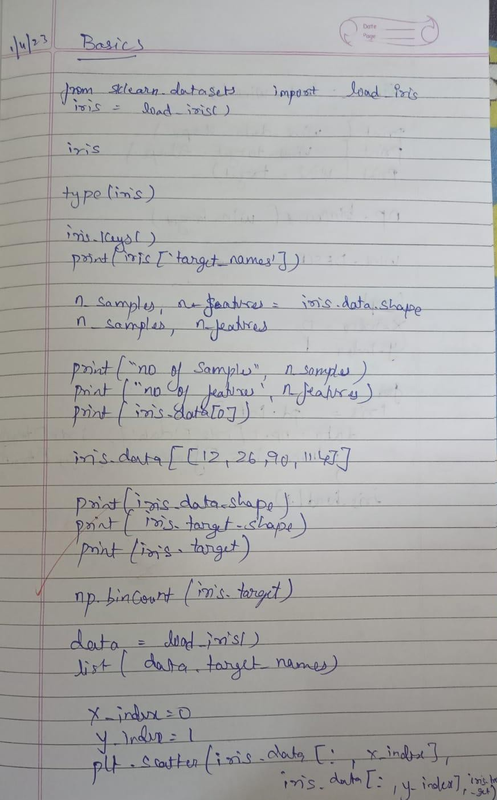

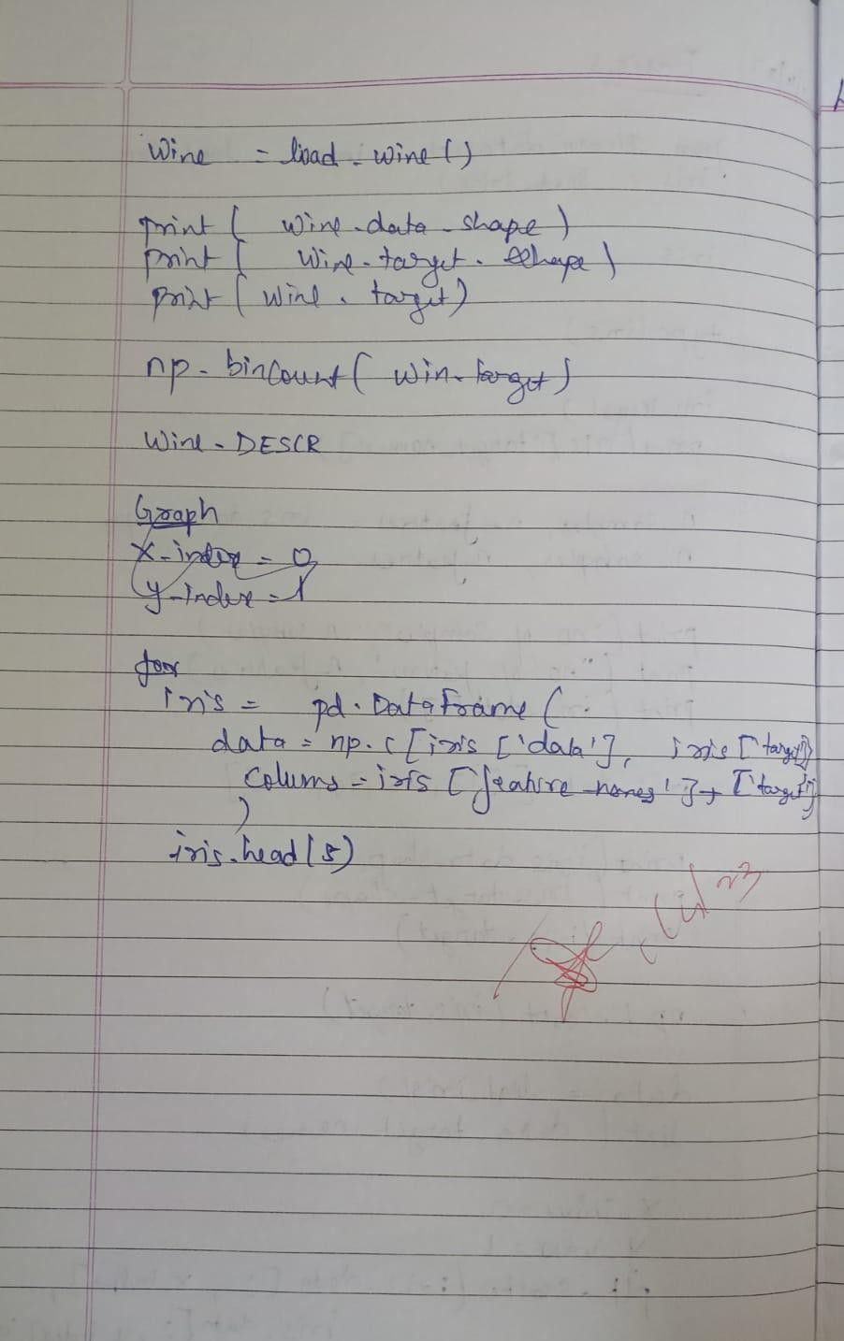

**(i)First data set**

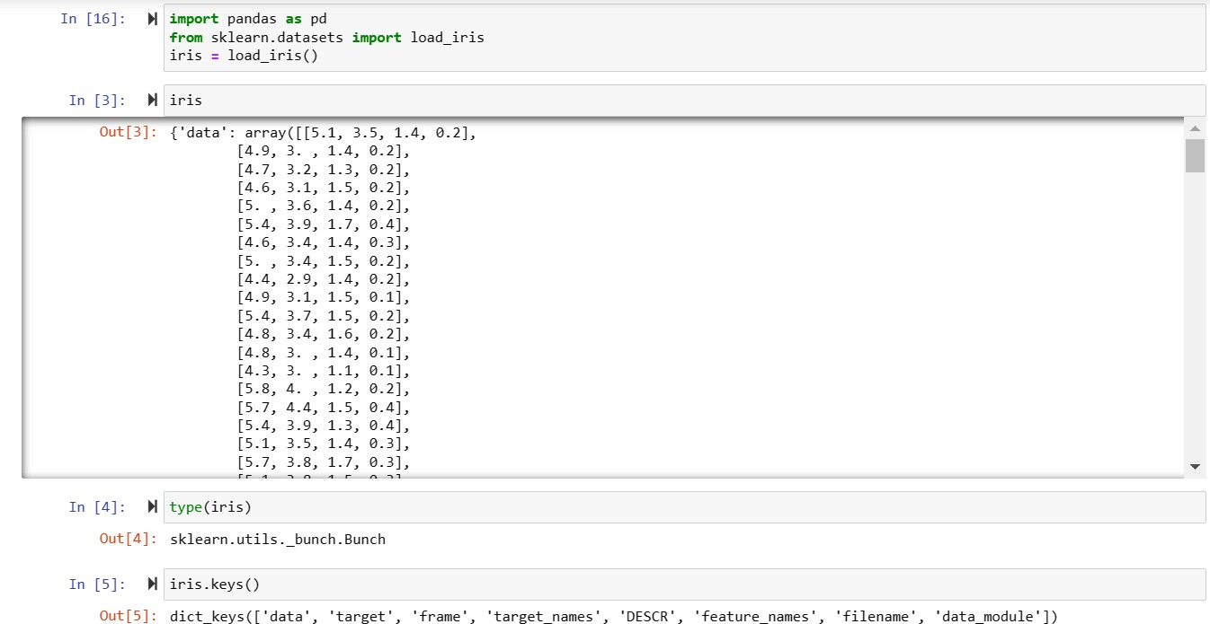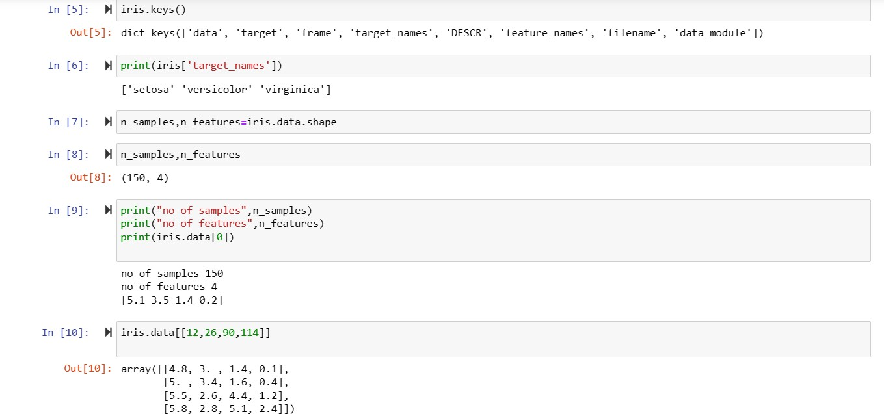

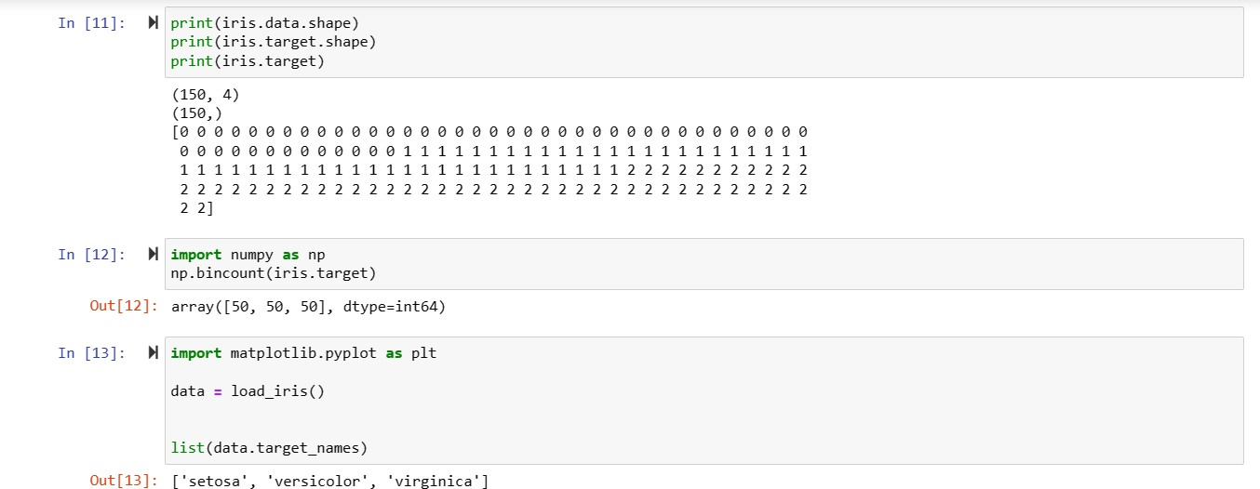

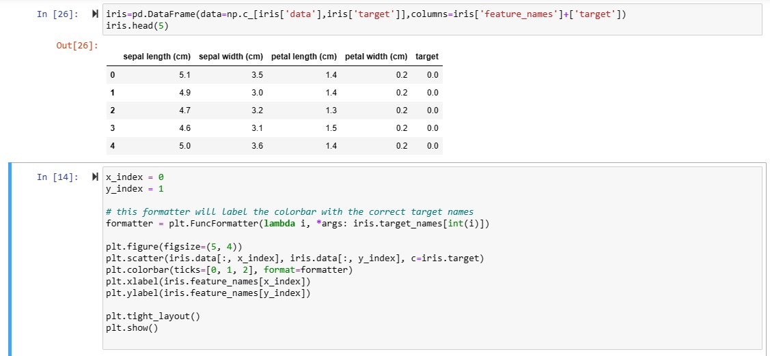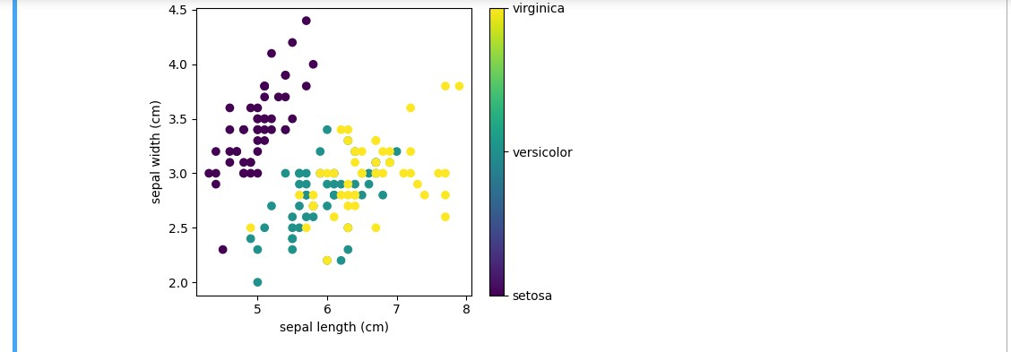

# b. Practice Exercise - Dataset Exploration – wine data set

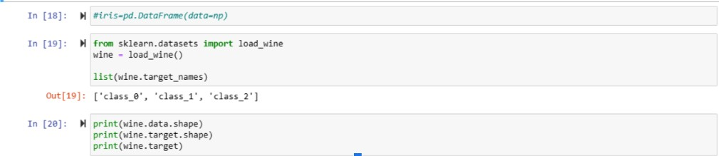

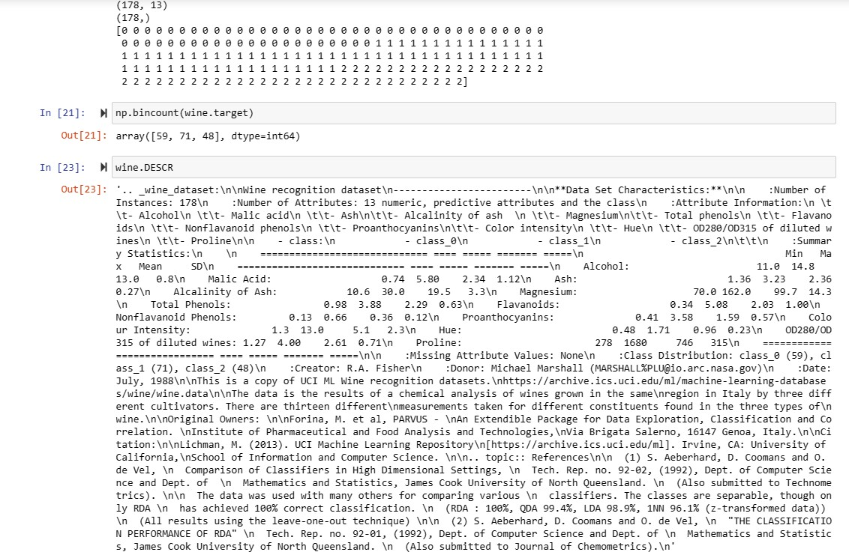

Date: 08.04.2023

Program 2 – Implement and demonstrate the FIND-S algorithm for finding the most specific hypothesis based on a given set of training data samples. Read the training data from a .CSV file

# Data set:

1. 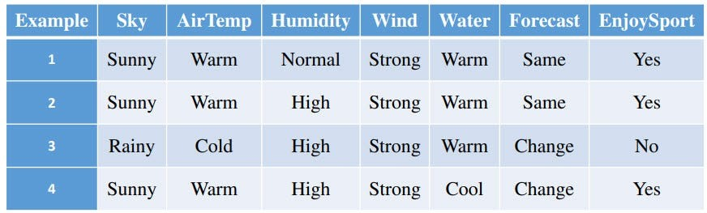Enjoysport

# Algorithm:

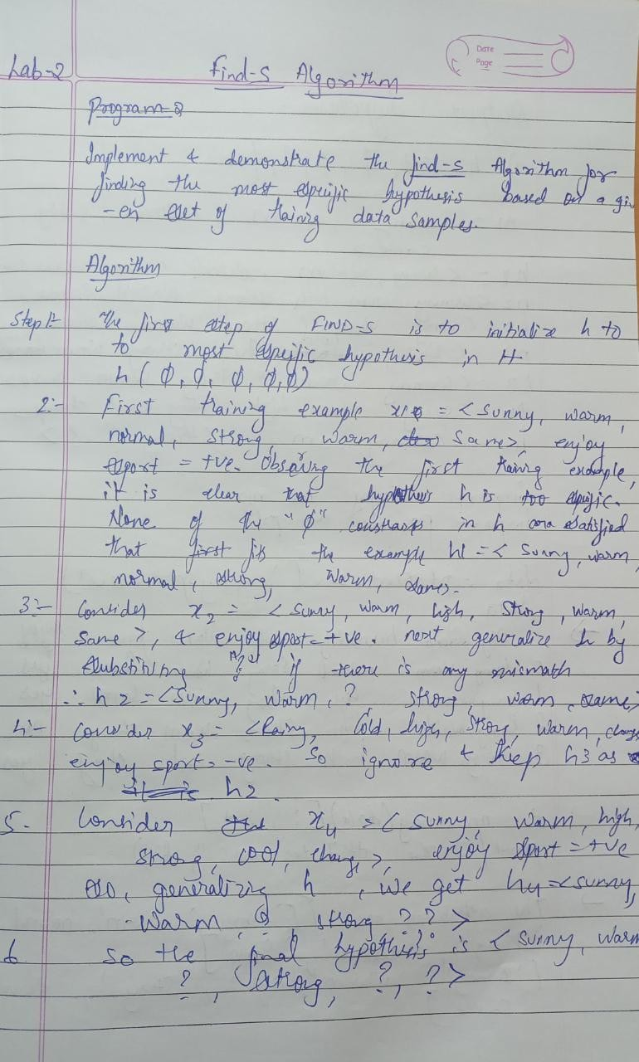Snapshot of handwritten algorithm (observation notebook)

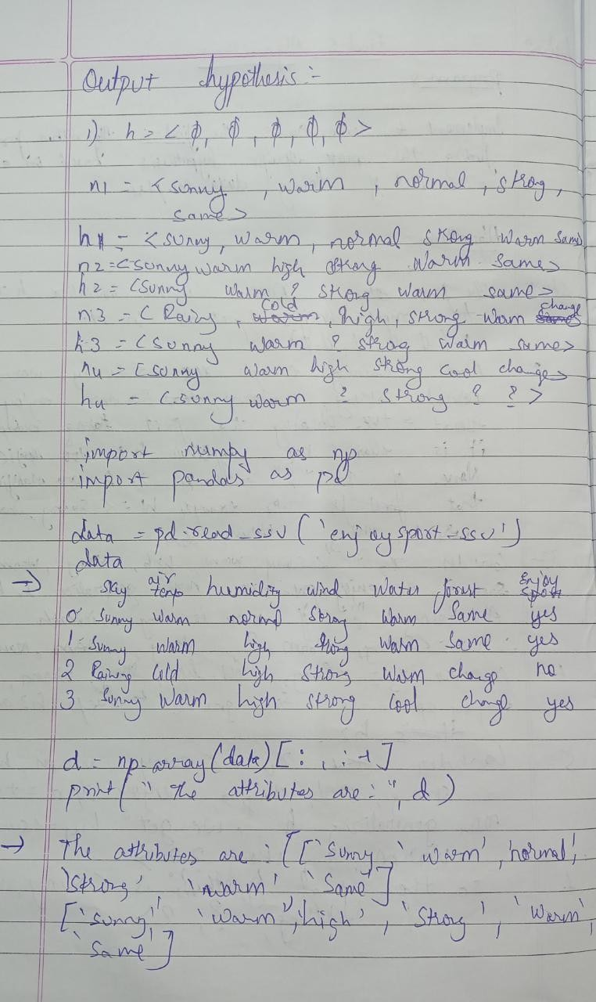

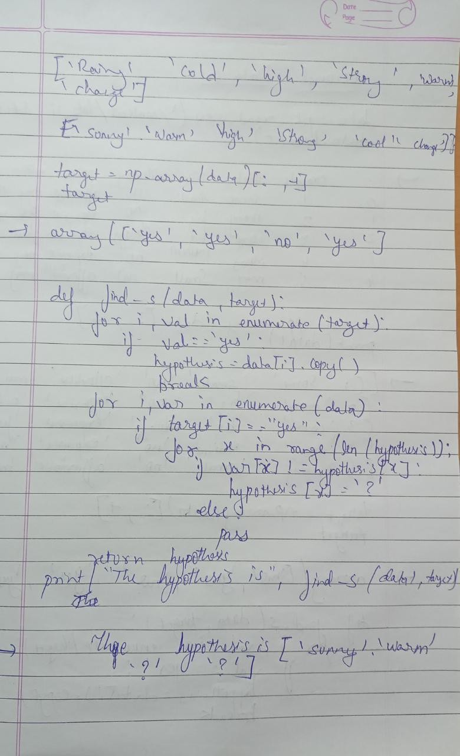

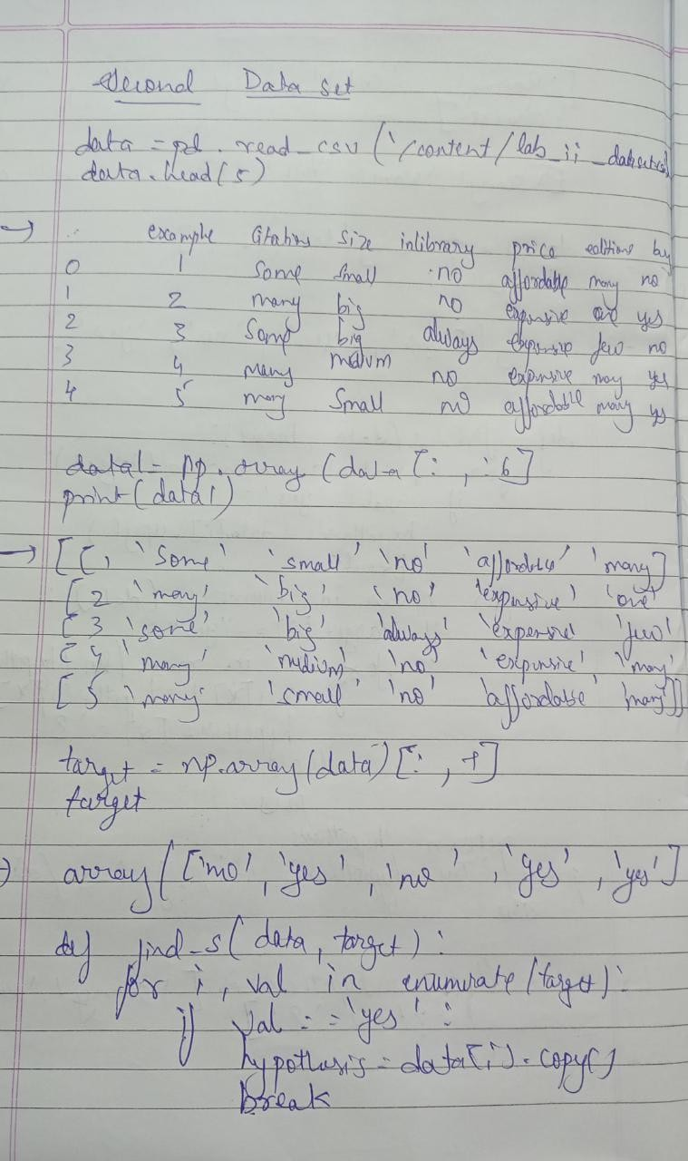

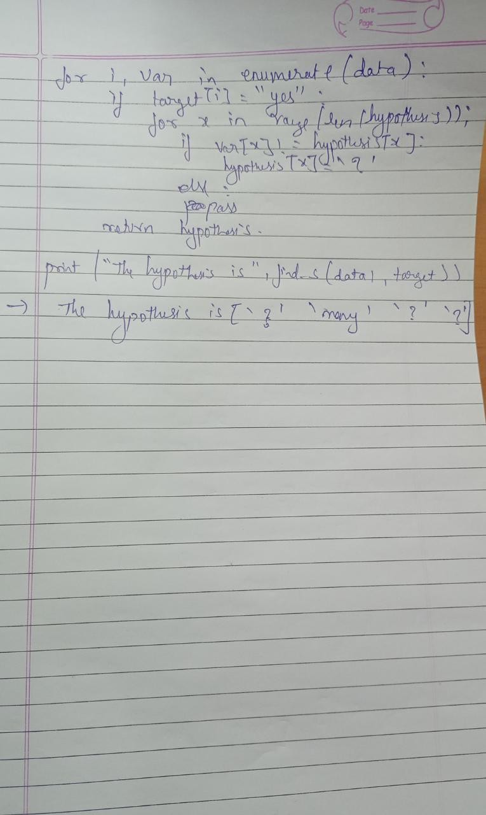

* 1. The first step of FIND-S is to initialize h to the most specific hypothesis in H **h — (Ø, Ø, Ø, Ø, Ø, Ø)**
  2. First training example x1 = < Sunny, Warm, Normal, Strong ,Warm ,Same>, EnjoySport = +ve. Observing the first training example, it is clear that hypothesis h is too specific. None of the “Ø” constraints in h are satisfied by this example, so each is replaced by the next more general constraint that fits the example **h1 = < Sunny, Warm, Normal, Strong ,Warm, Same>**.
  3. Consider the second training example x2 = < Sunny, Warm, High, Strong, Warm, Same>, EnjoySport = +ve. The second training example forces the algorithm to further generalize h, this time substituting a “?” in place of any attribute value in h that is not satisfied by the new example. Now **h2 =< Sunny, Warm, ?, Strong, Warm, Same>**
  4. Consider the third training example x3 =< Rainy, Cold, High, Strong, Warm, Change>,EnjoySport = — ve. The FIND-S algorithm simply ignores every negative example. So the hypothesis remain as before, so **h3 =< Sunny, Warm, ?, Strong, Warm, Same>**
  5. Consider the fourth training example x4 =<Sunny,Warm,High,Strong, Cool,Change>, EnjoySport =+ve. The fourth example leads to a further generalization of h as **h4 =< Sunny, Warm, ?, Strong, ?, ?>**
  6. So the final hypothesis is **< Sunny, Warm, ?, Strong, ?, ?>**

Uploading the csv file.

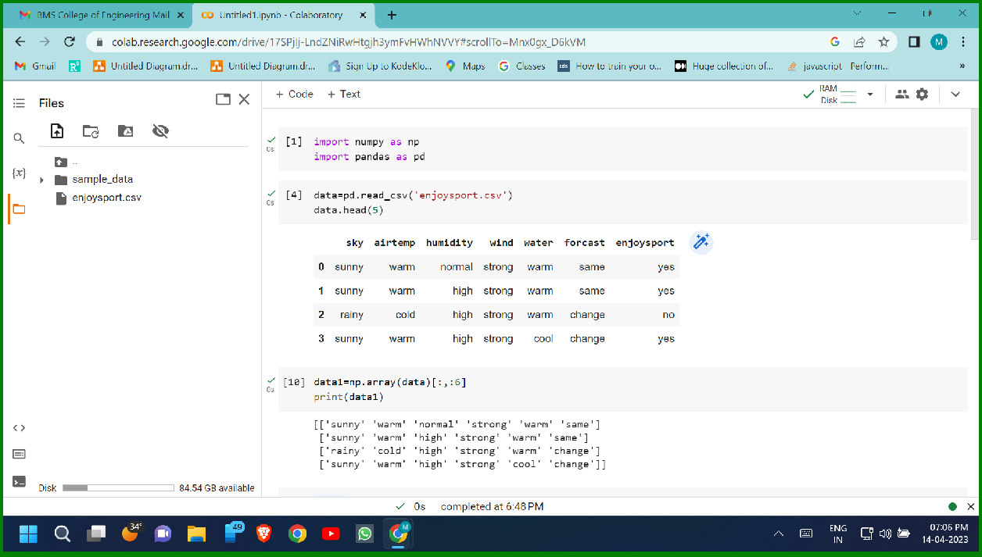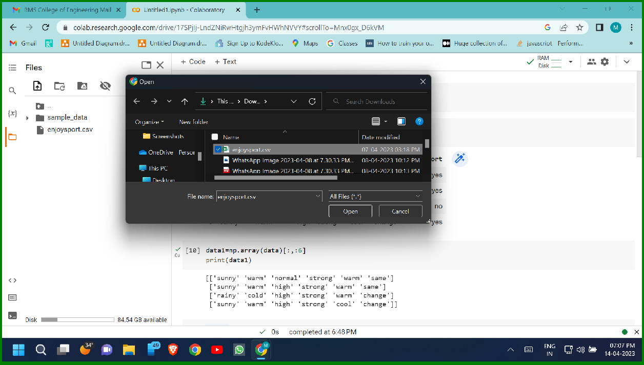

# Program:

Screenshot of the program executed

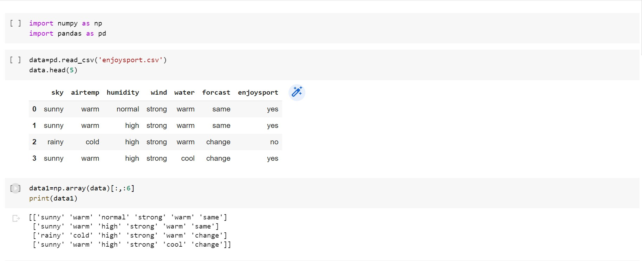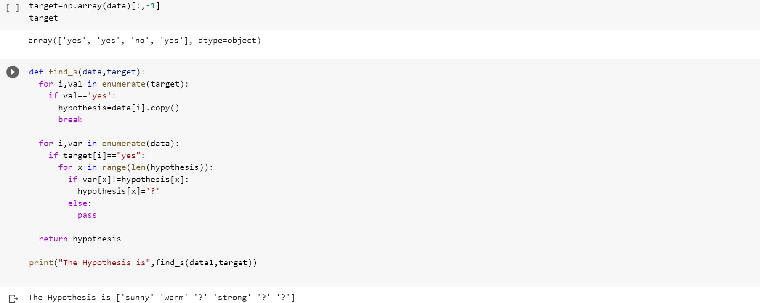

# Output:

Screenshot of the executed output



# Purchase.csv

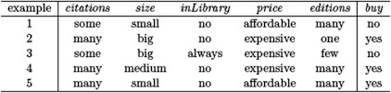

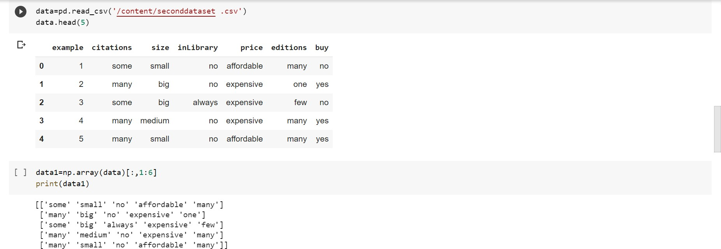

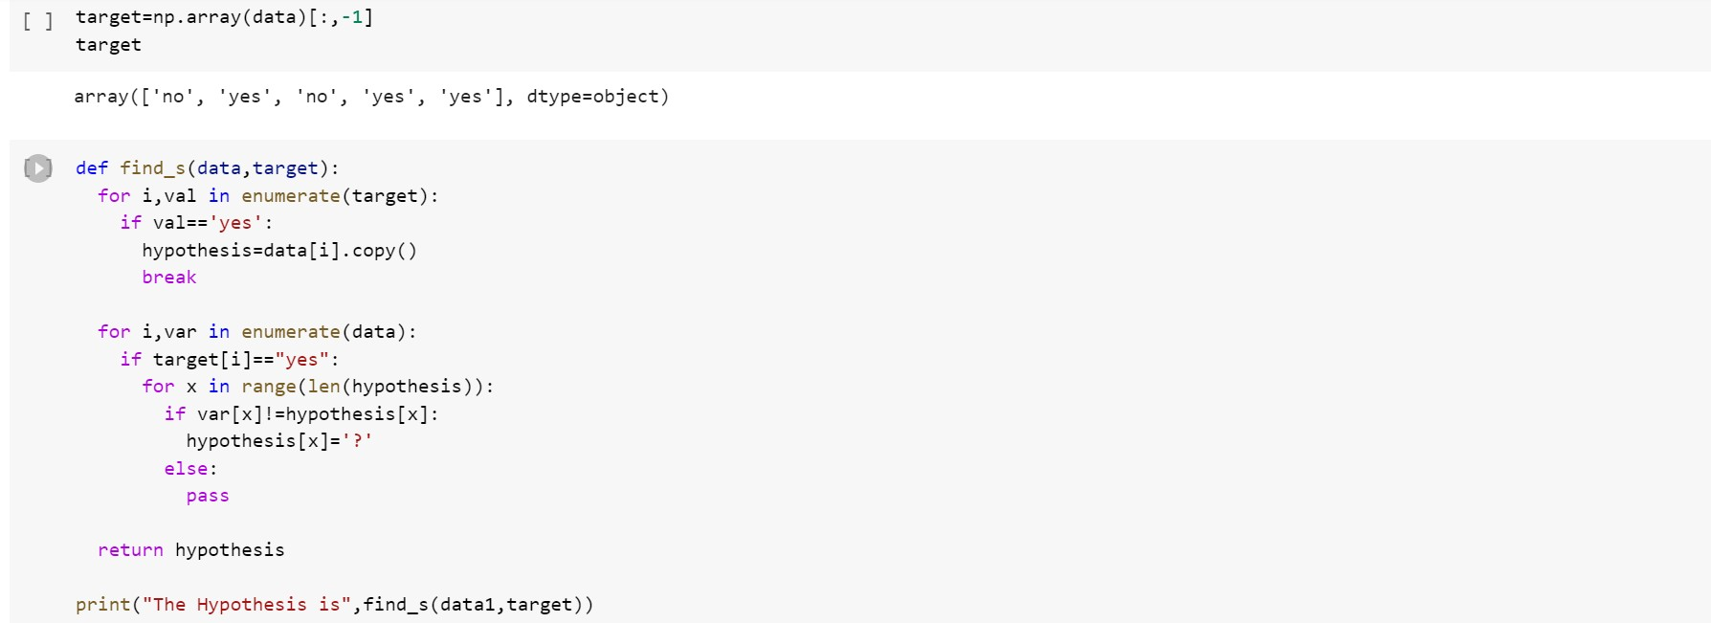

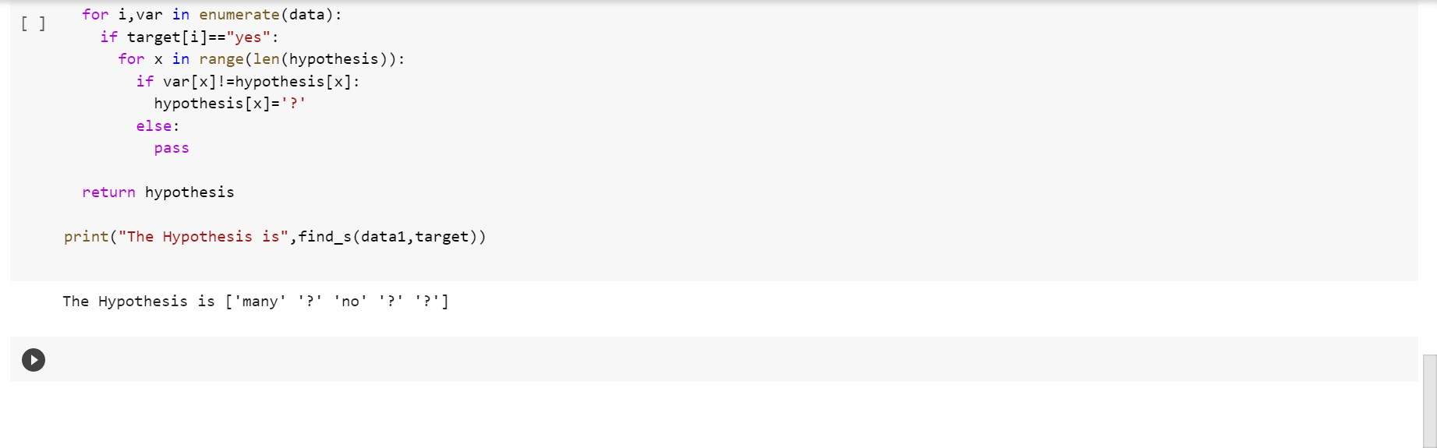

**Output:**

Screenshot of the executed output

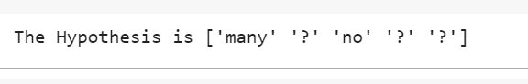

**Program 3:**

For a given set of training data examples stored in a .CSV ﬁle, implement and demonstrate the

Candidate-Elimination algorithm to output a description of the set of all hypotheses consistent with the training examples.

Data set:Enjoysport

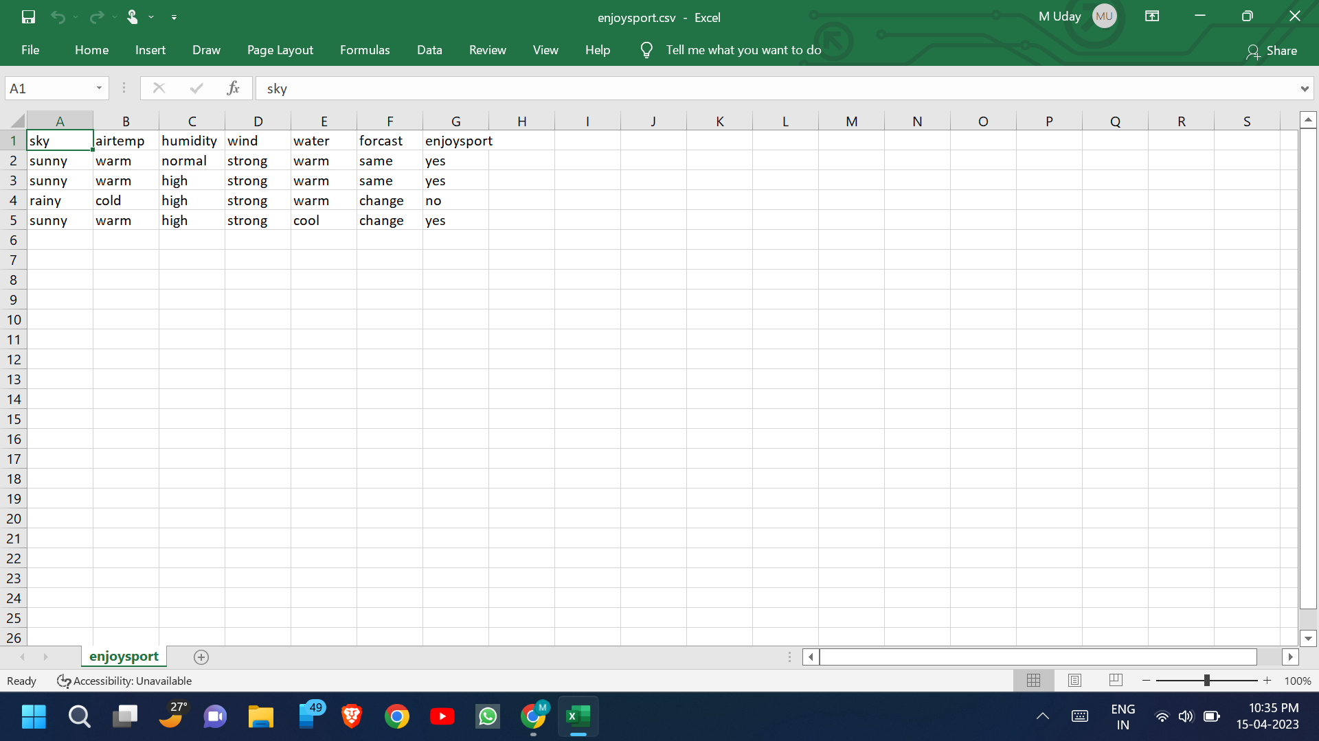Uploading the csv file:

Algorithm:

Handwritten observation:

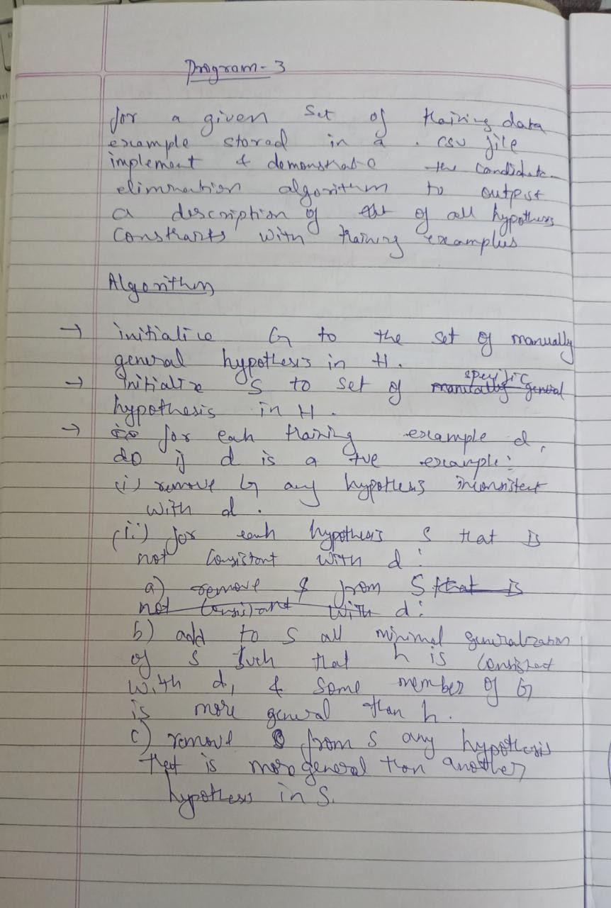

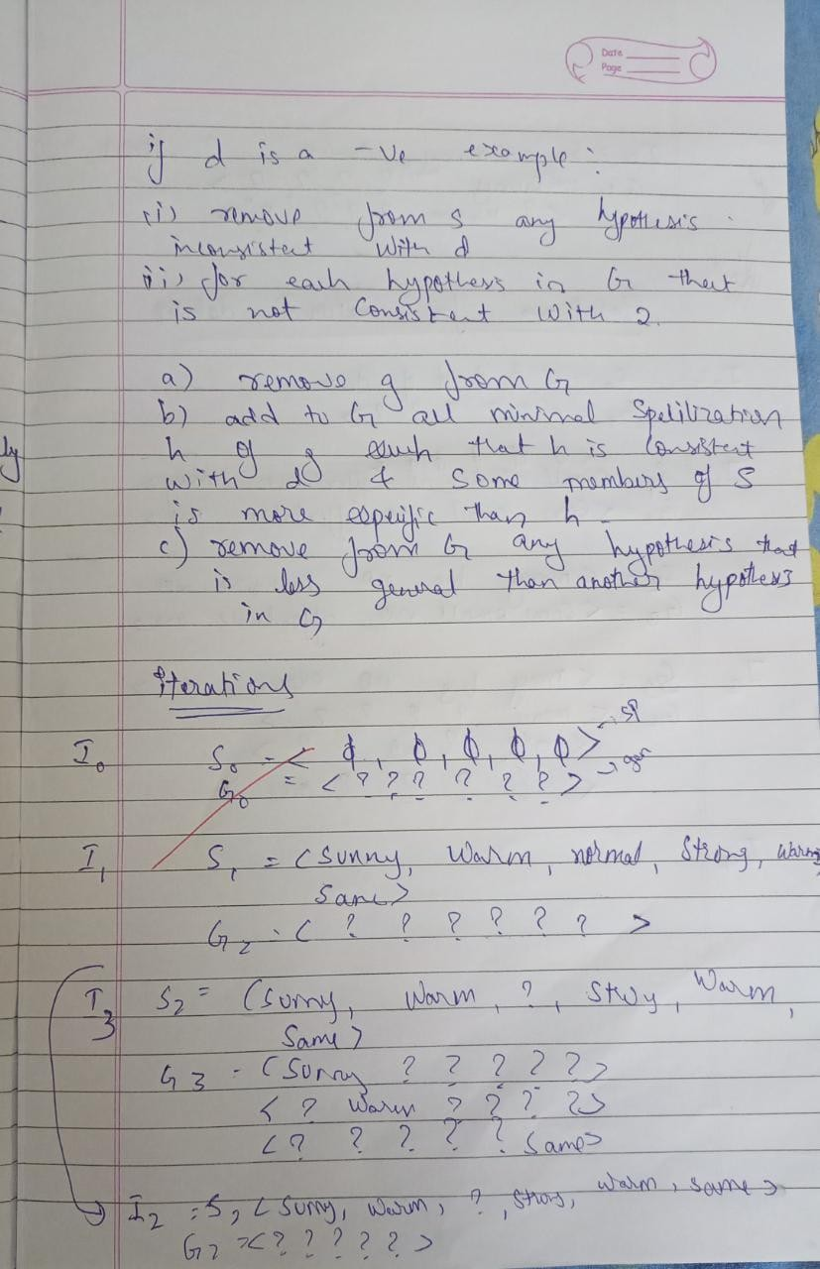

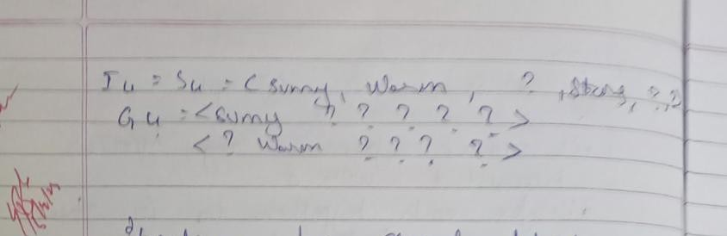

**Program:**

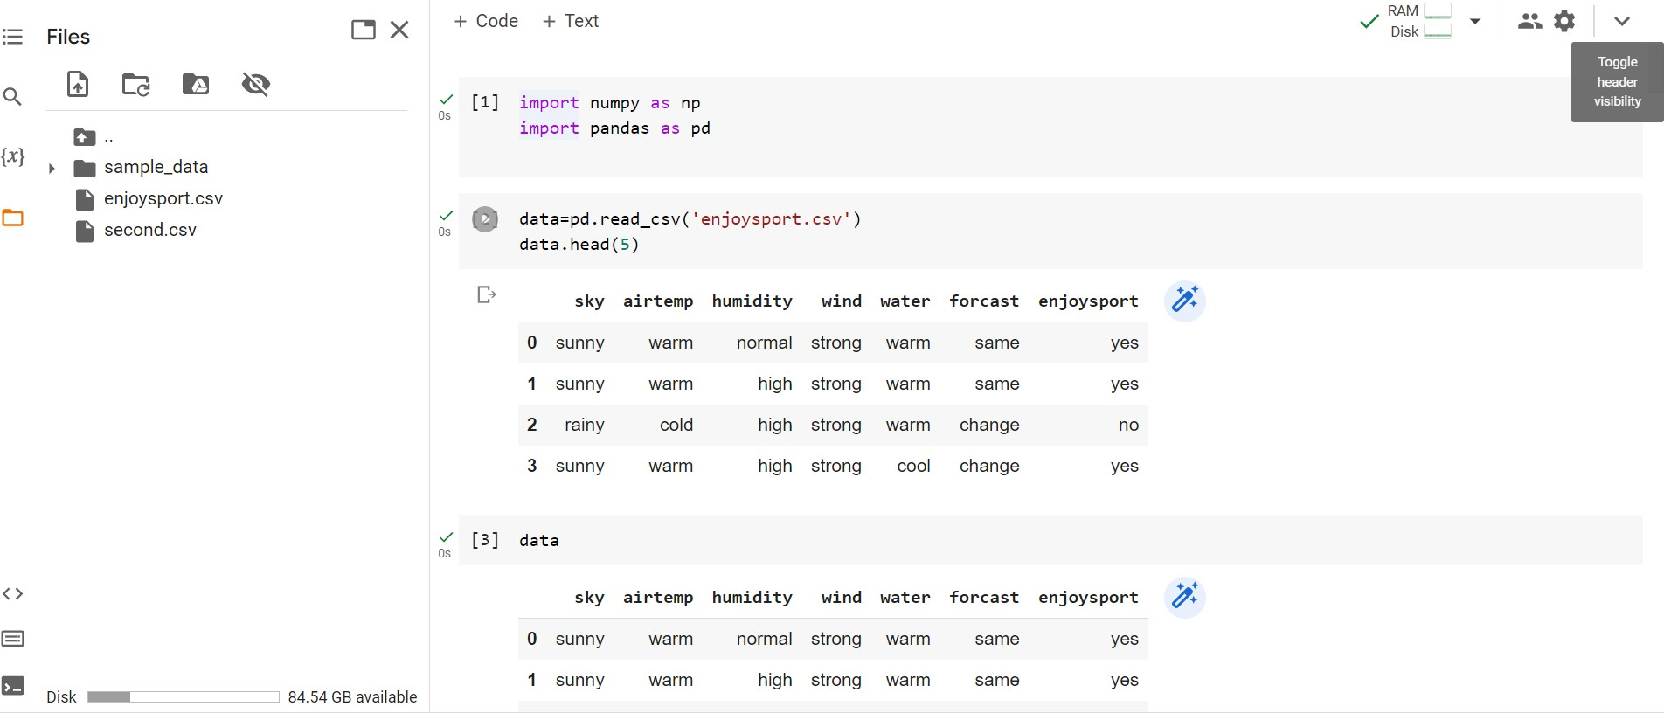First data set

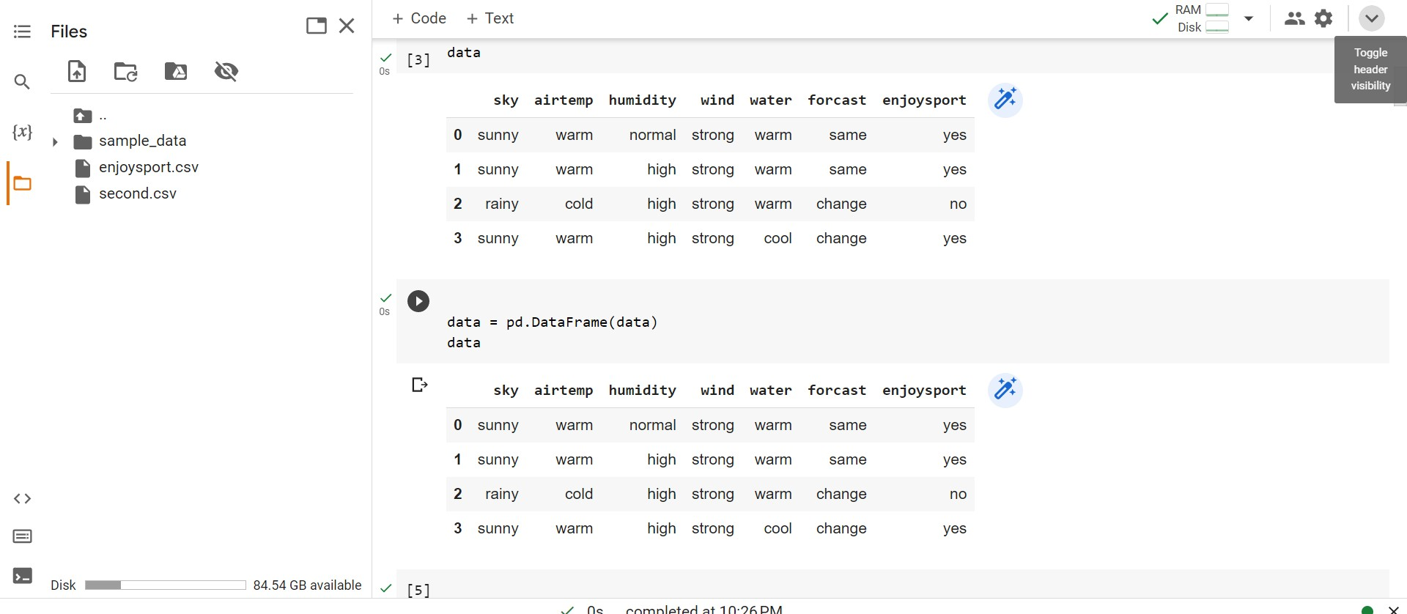

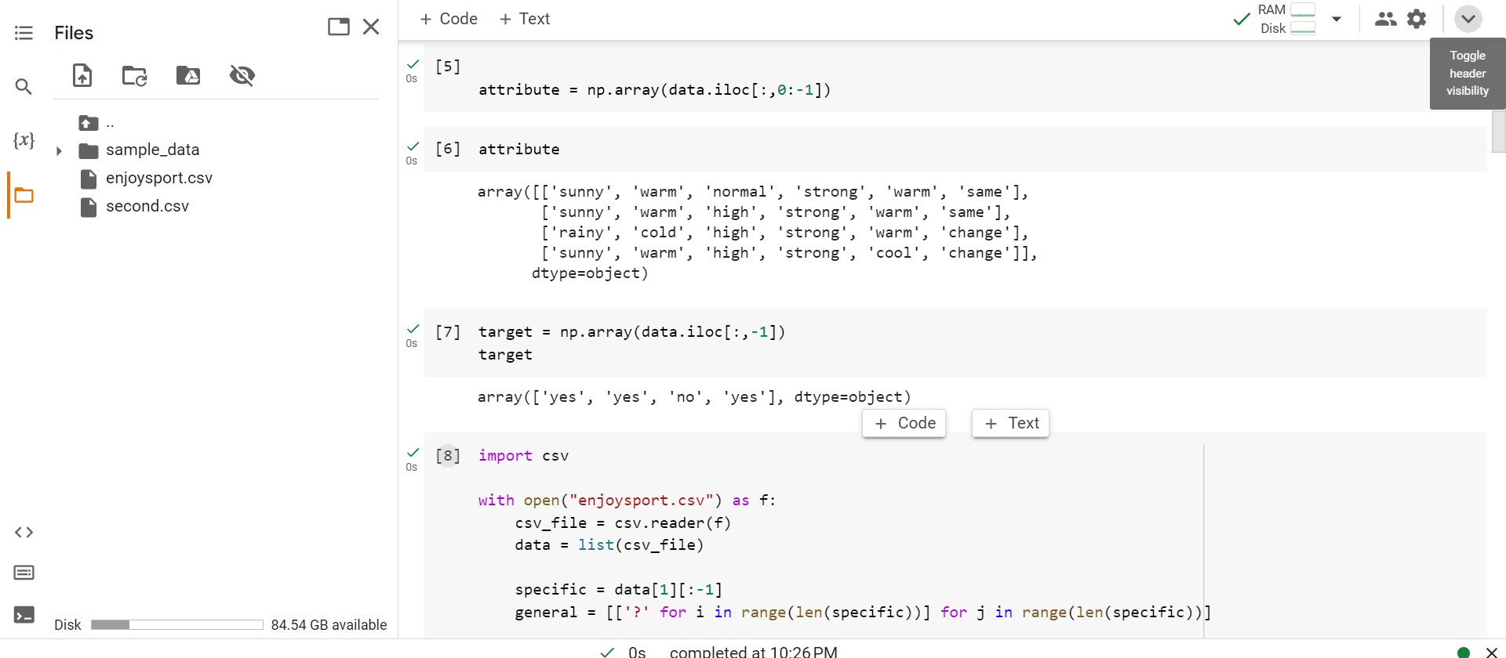

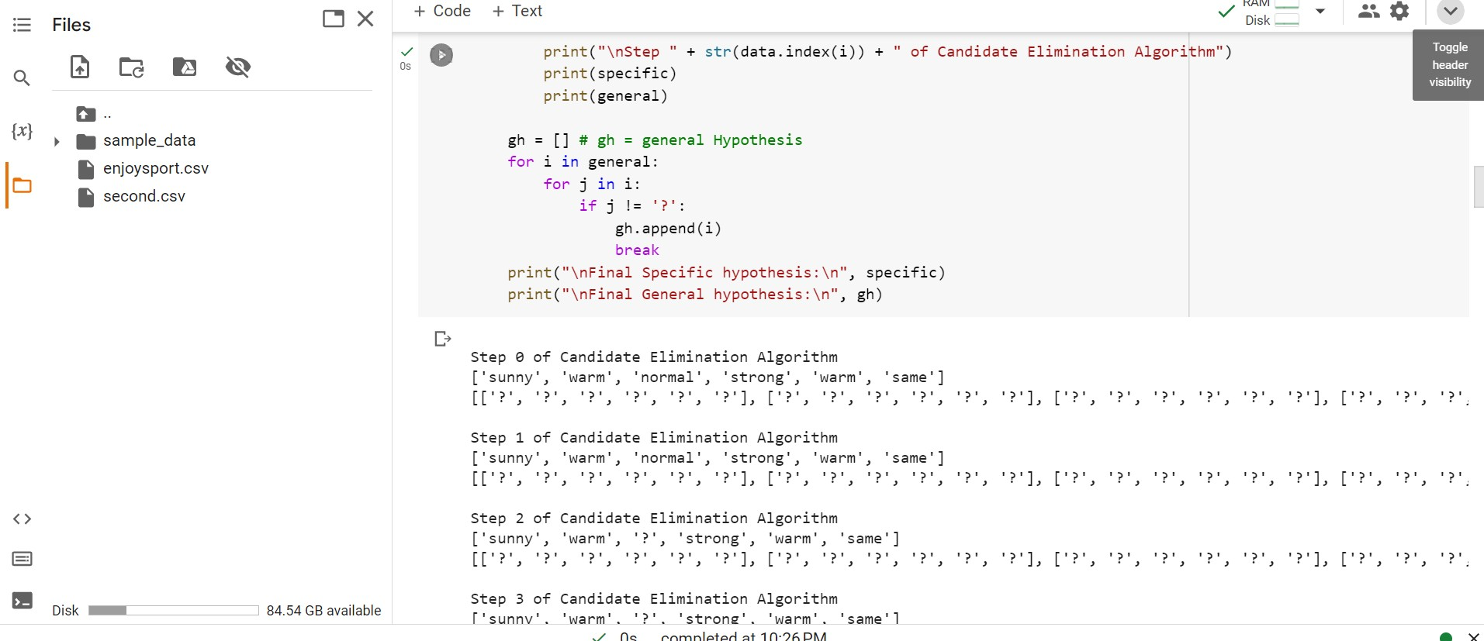

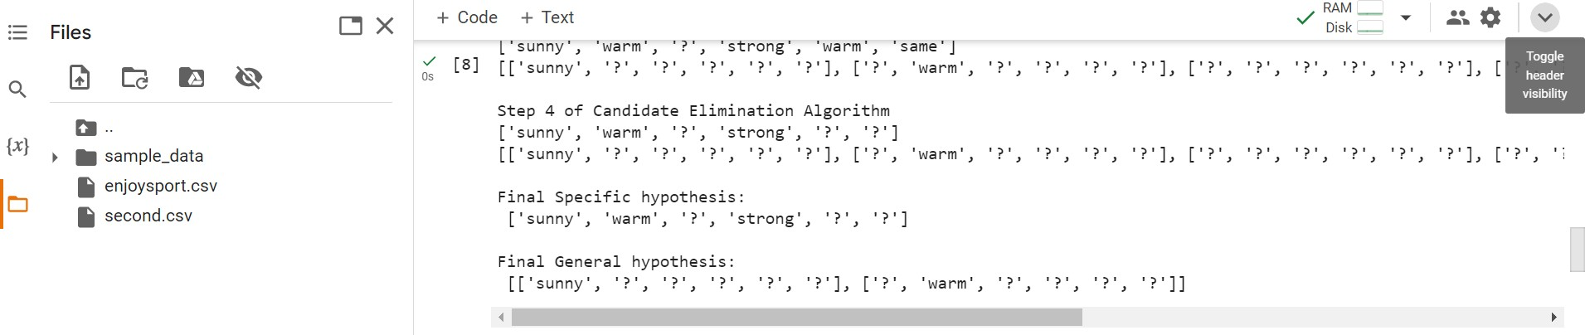

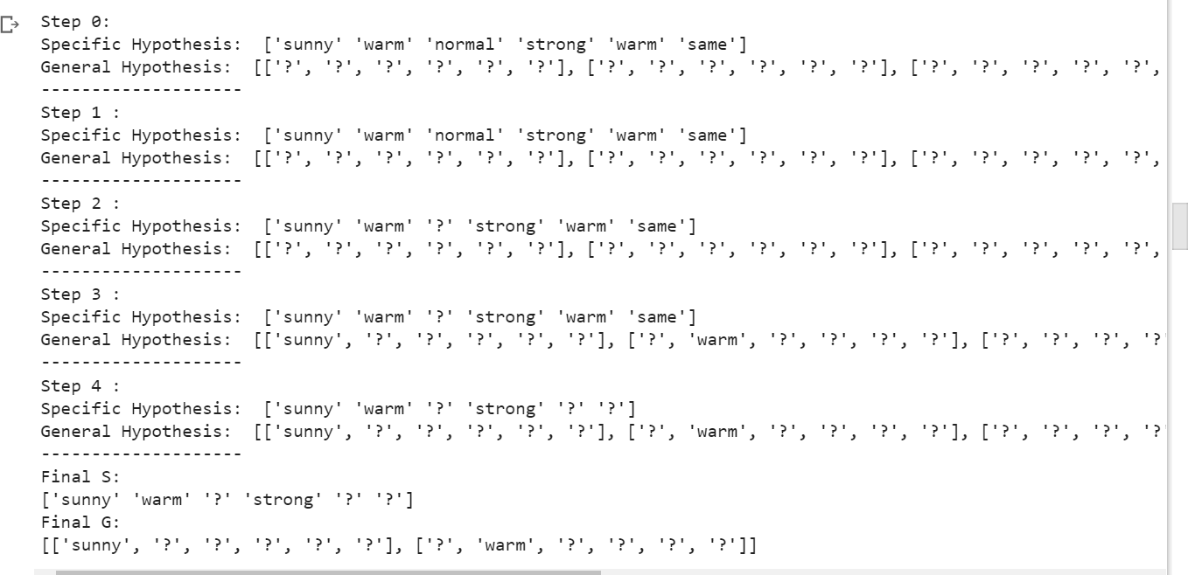Output:

**Second Dataset:**



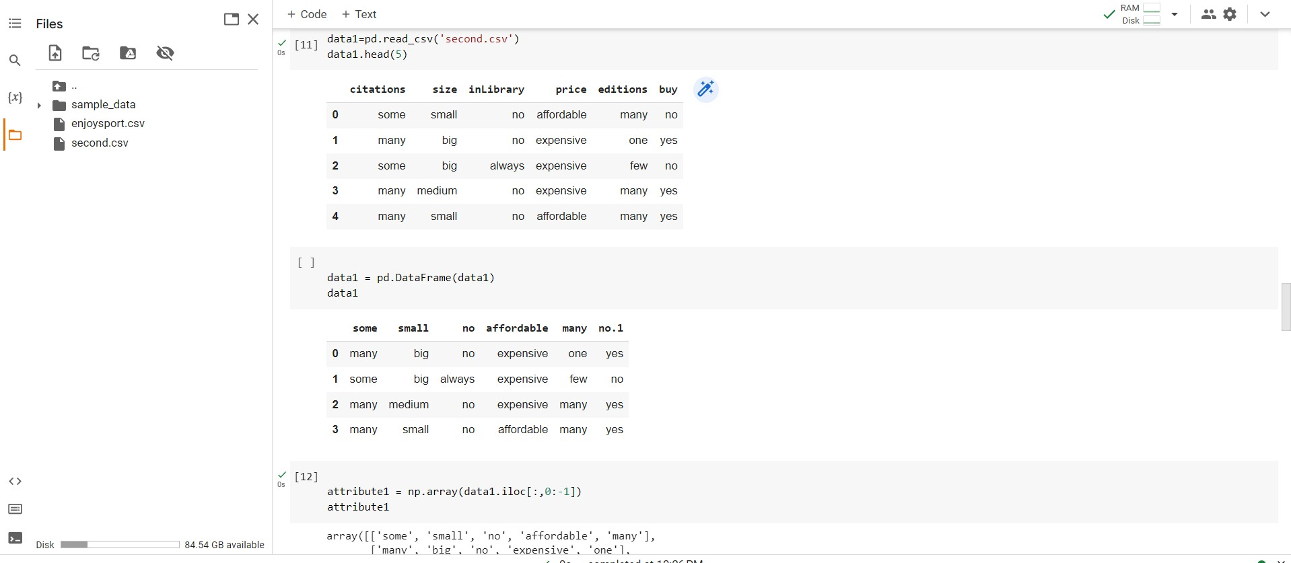

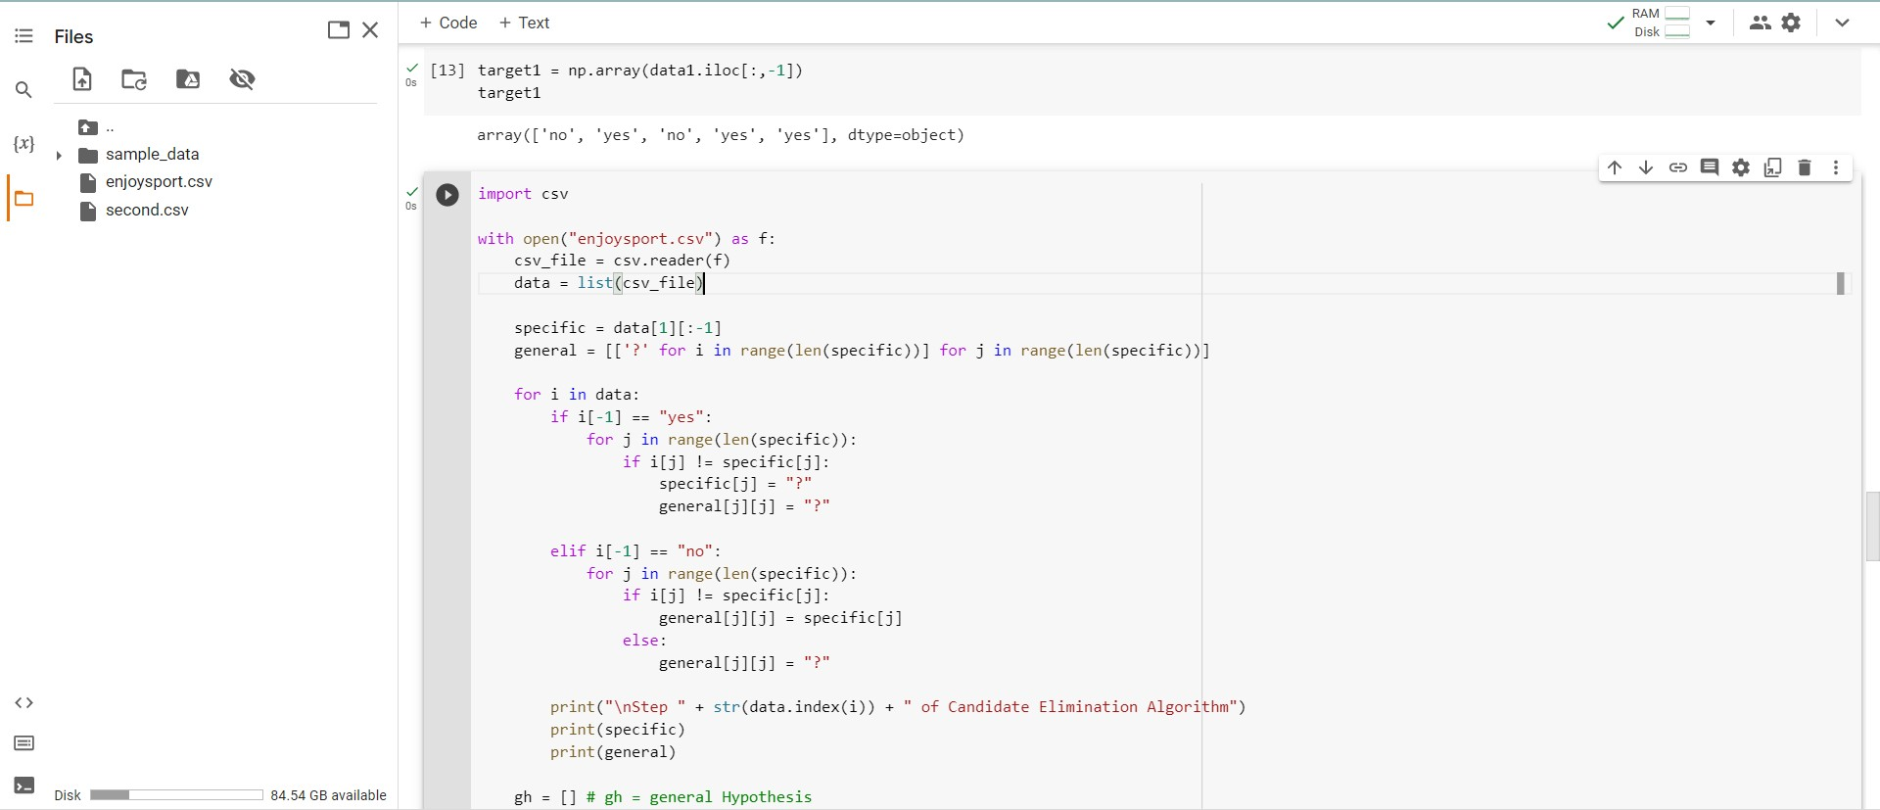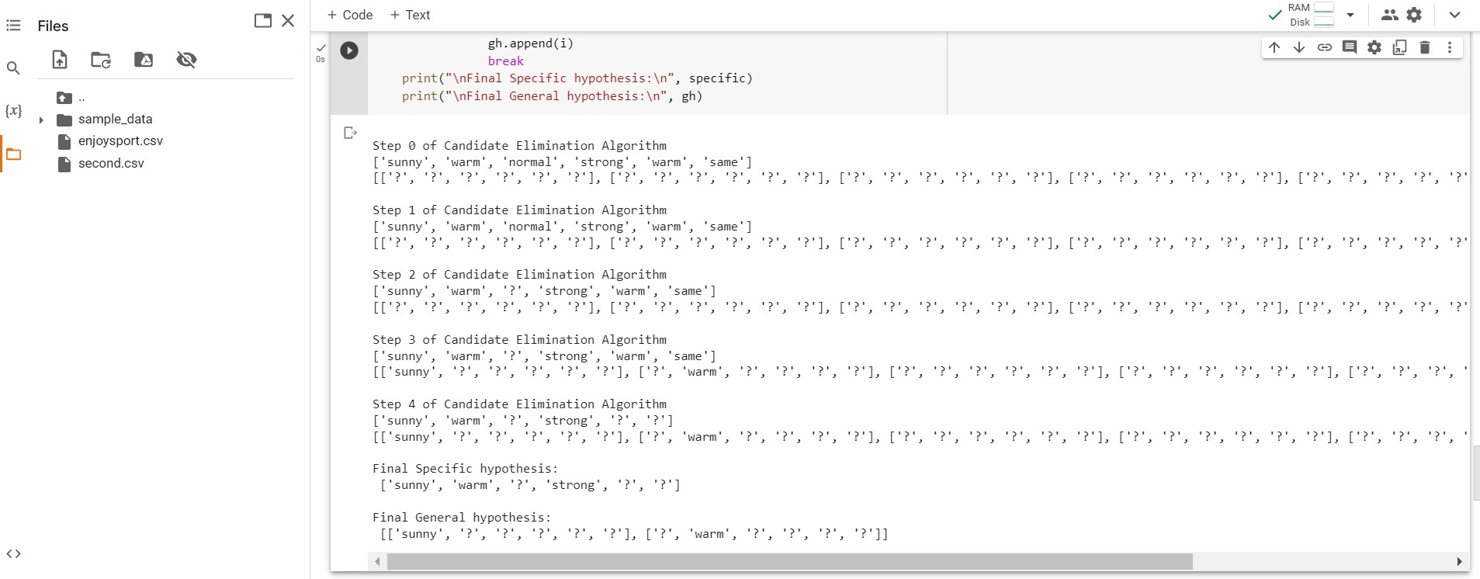

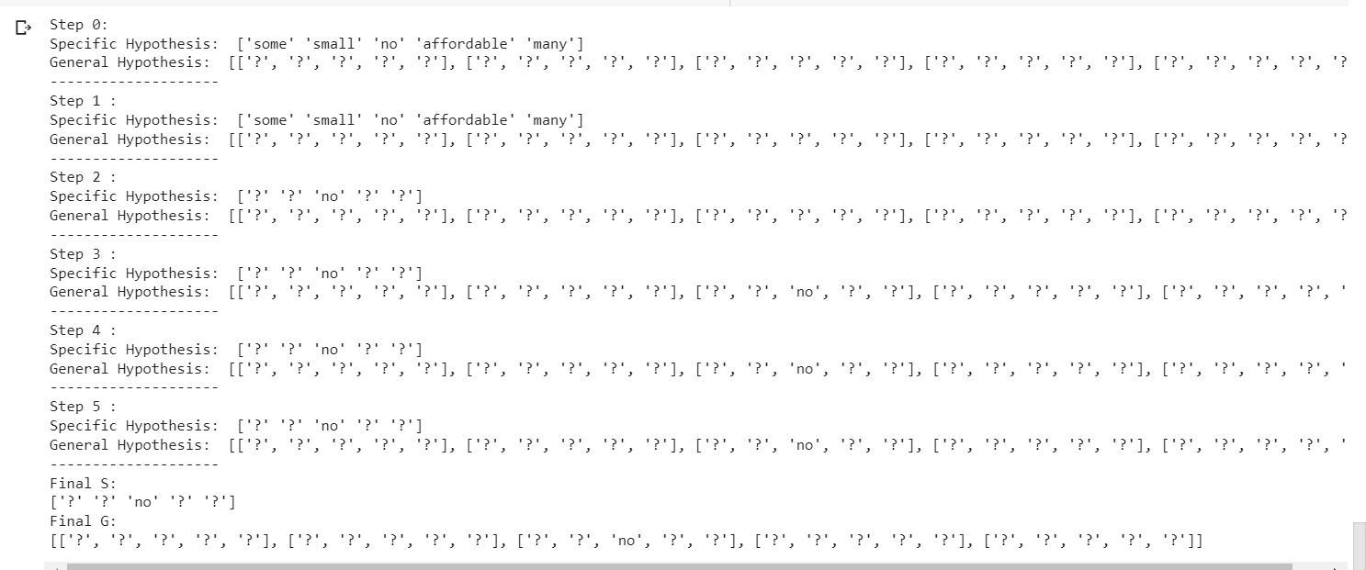**Output:**

# Date:29-04-2023

**Program-4:**

# Write a program to demonstrate the working of the decision tree based ID3 algorithm. Use an appropriate data set for building the decision tree and apply this knowledge to classify a new sample.

**Dataset: Playtennis**

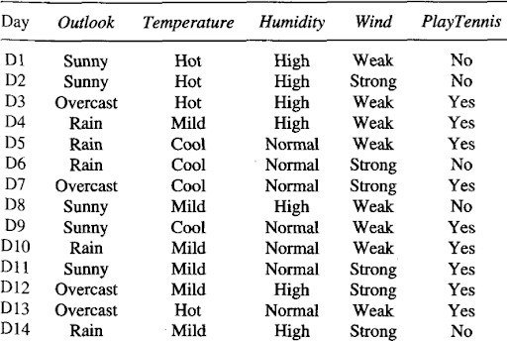

# Observation:

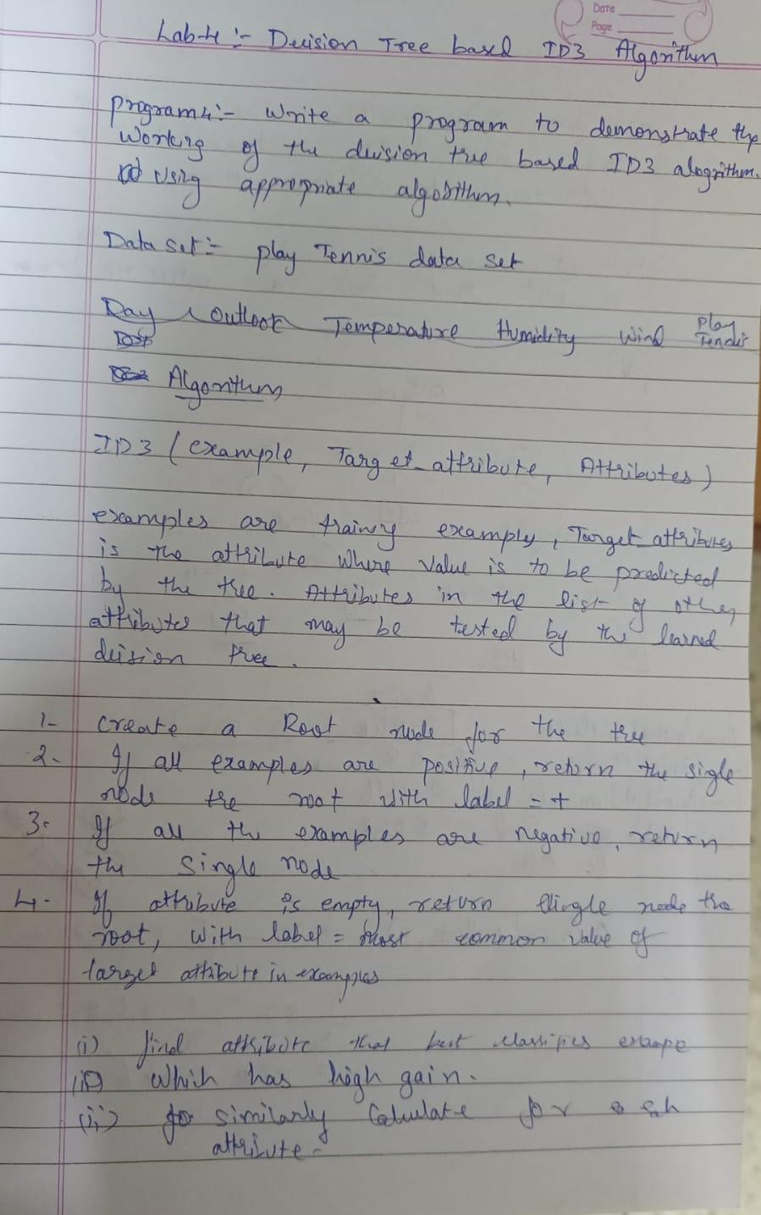

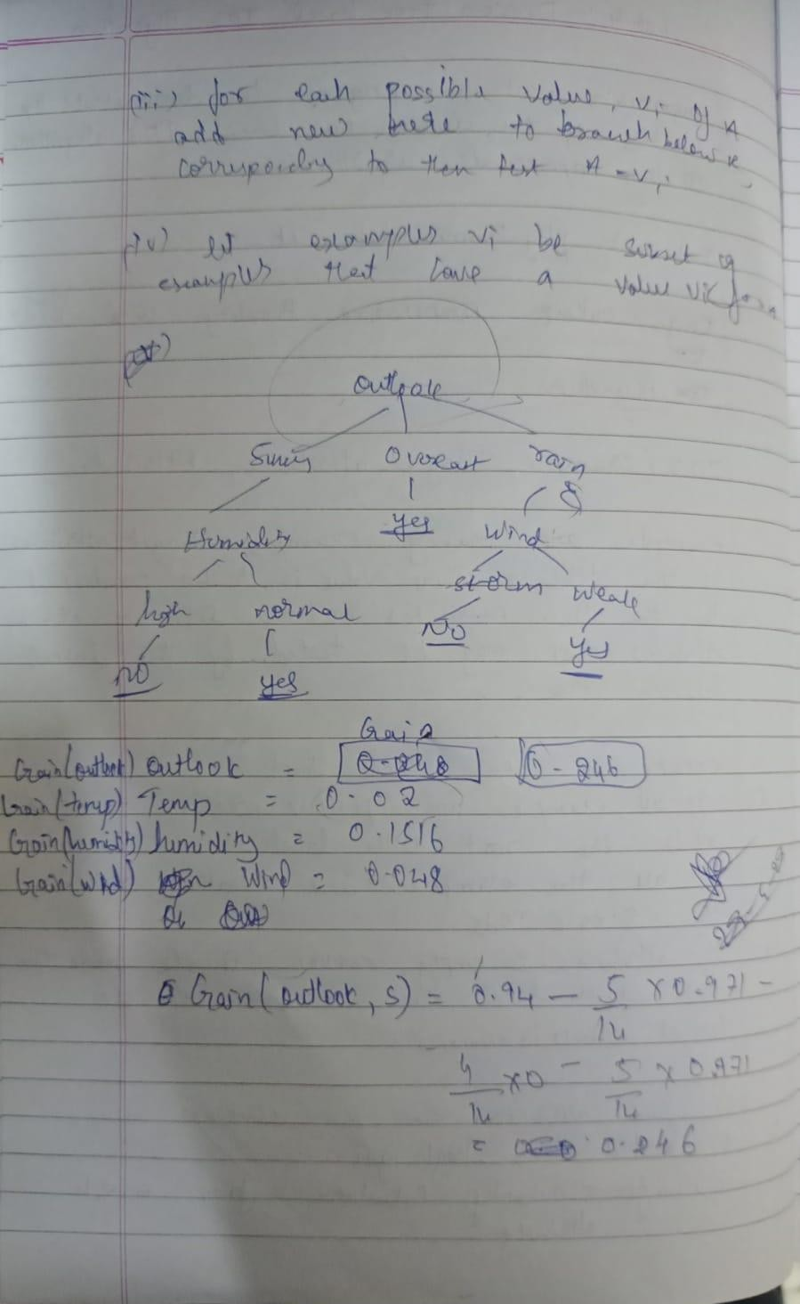

**CSV File:**

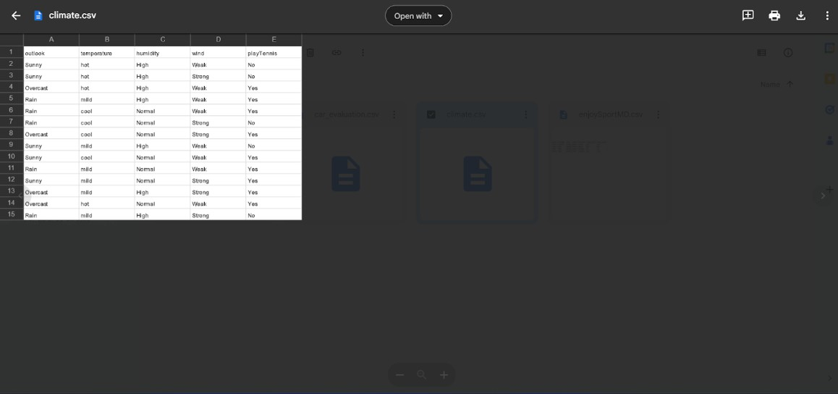

# Code:

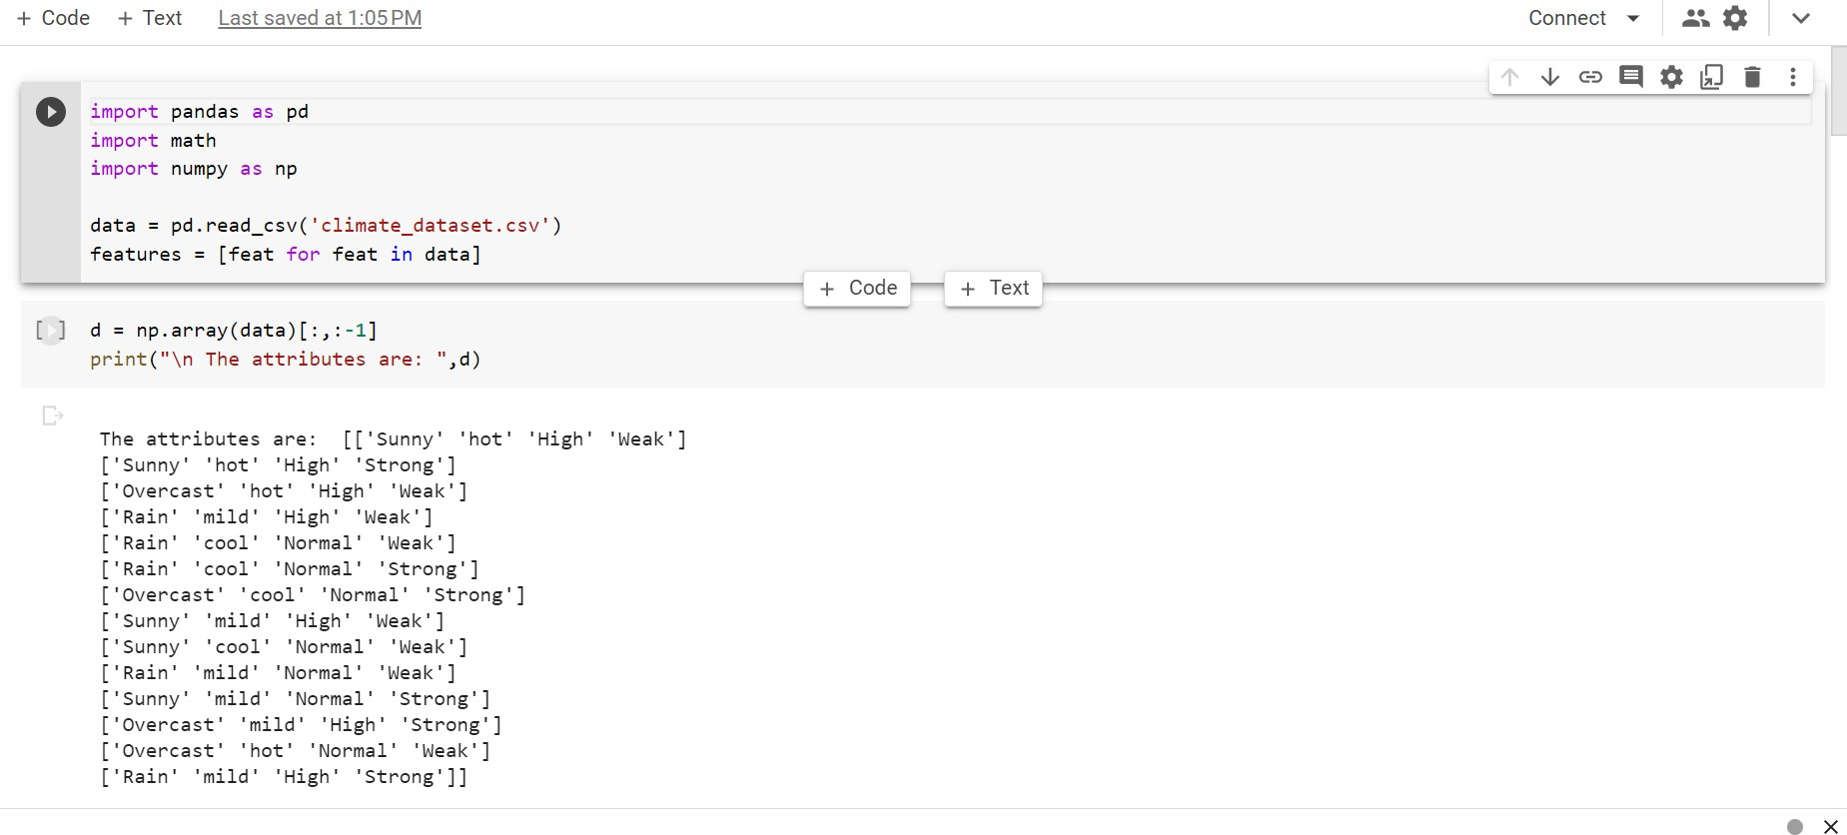

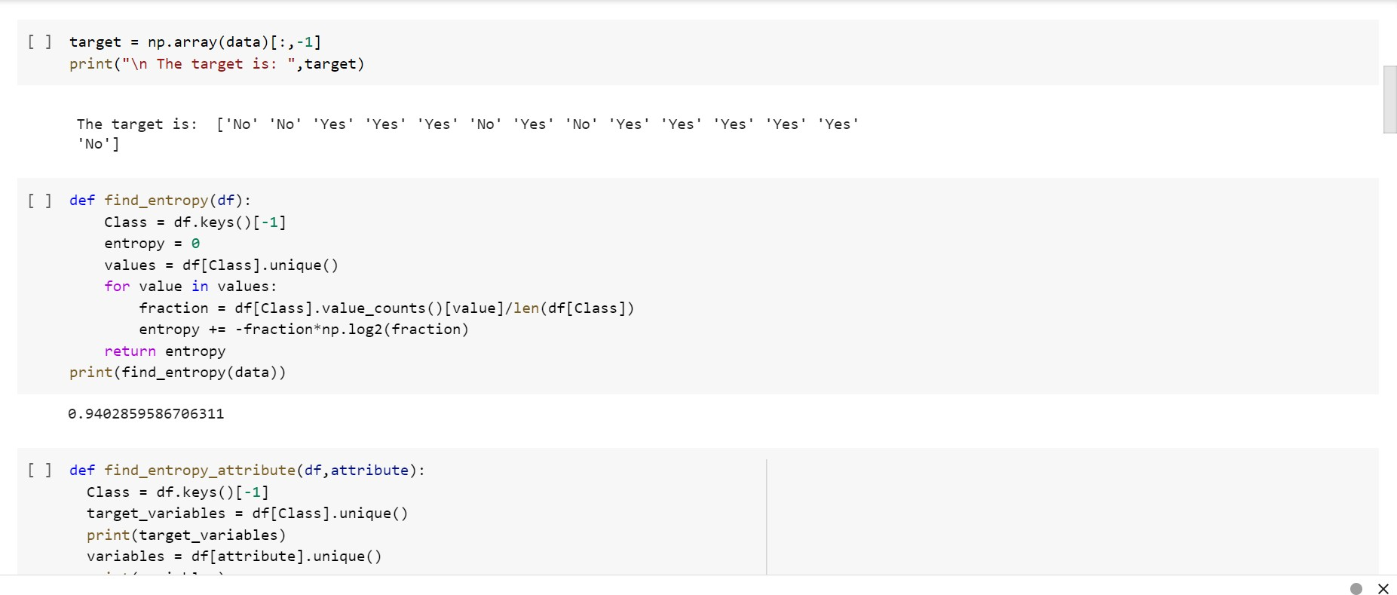

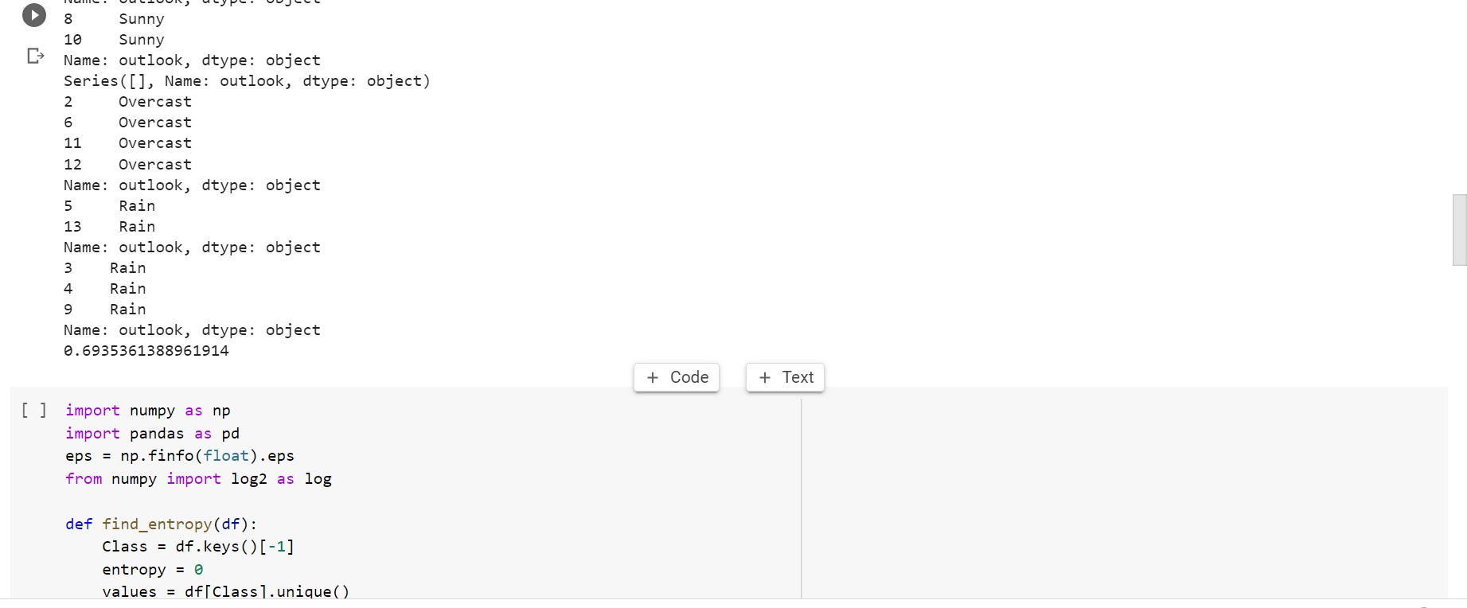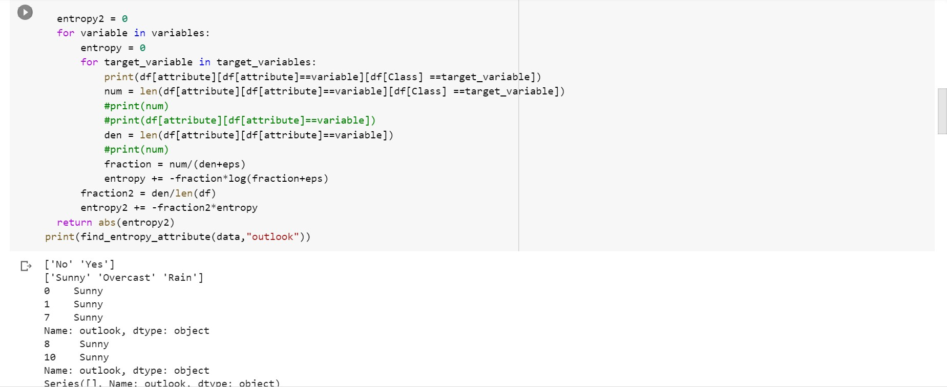

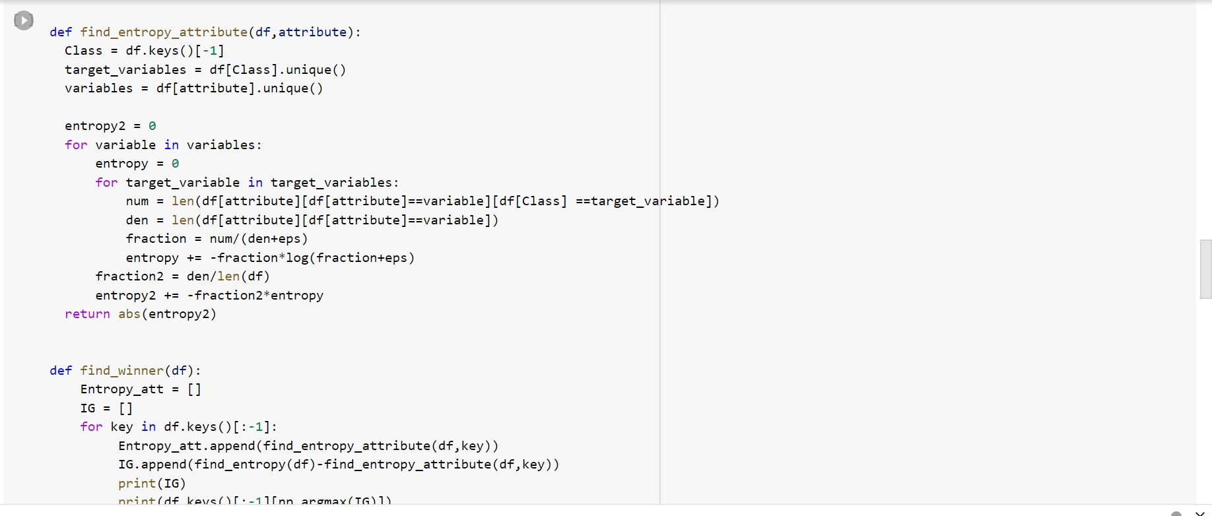

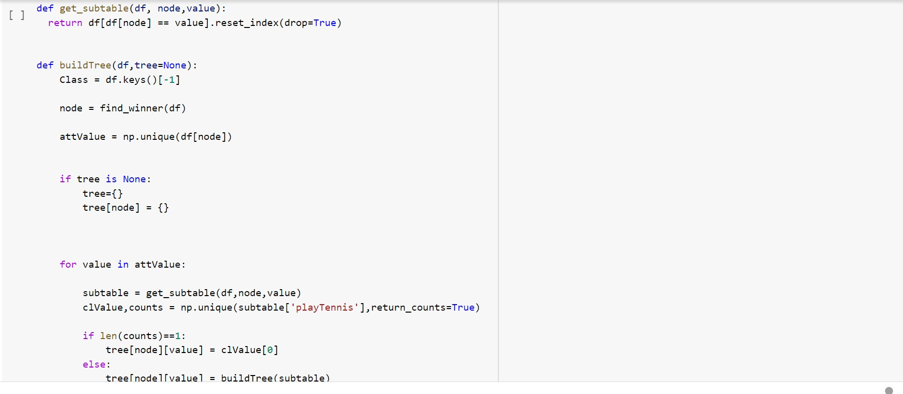

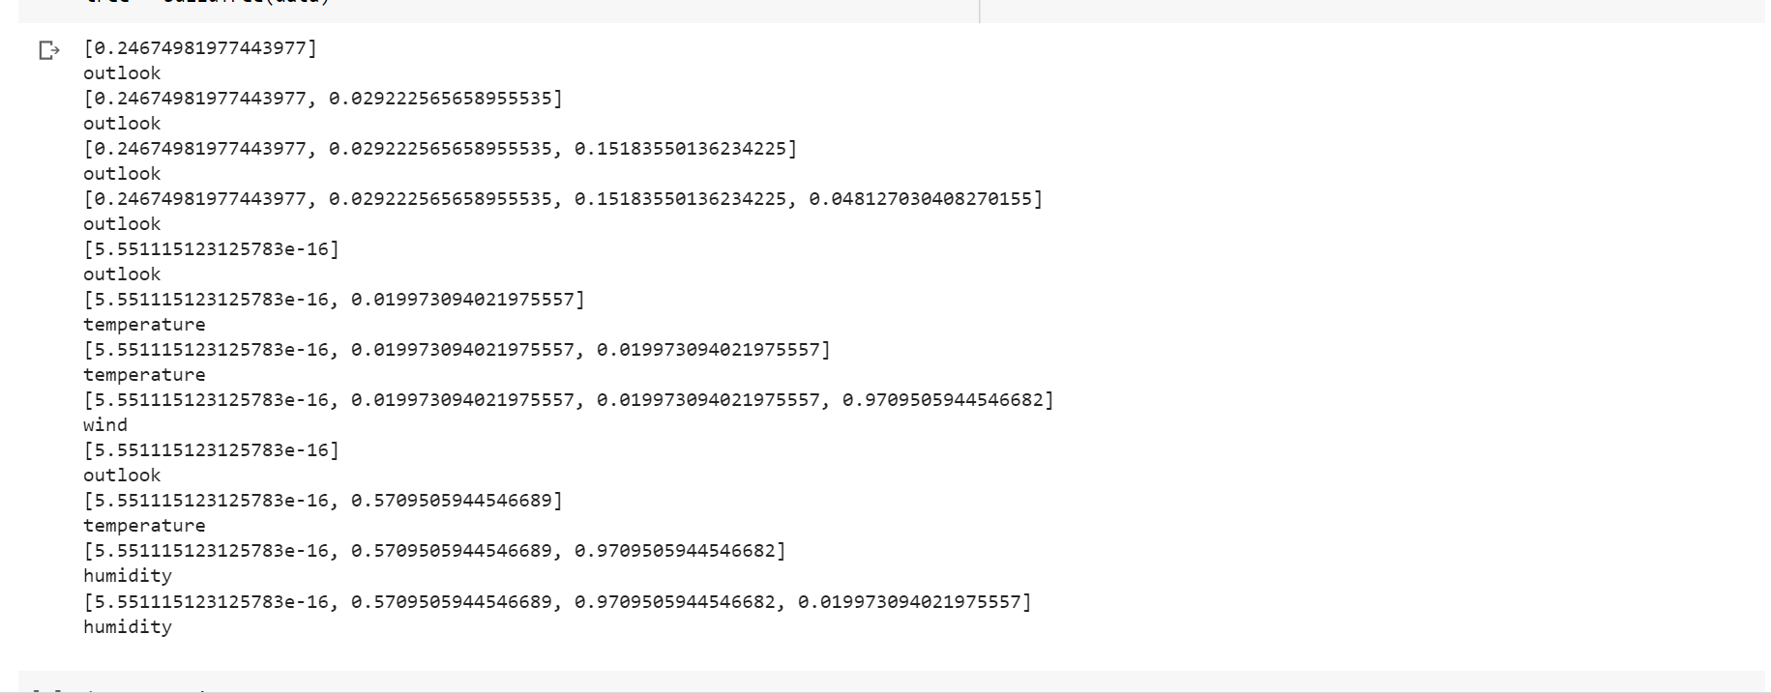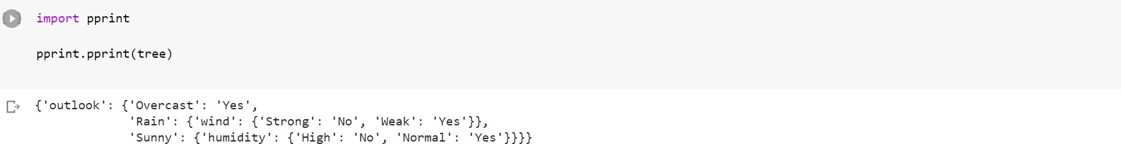

**Output**



# Date:12-05-2023

**Program-4:**

# Write a program to demonstrate the working simple Linear Regression algorithm. Use an appropriate data set to train and test

**Dataset: Salary**

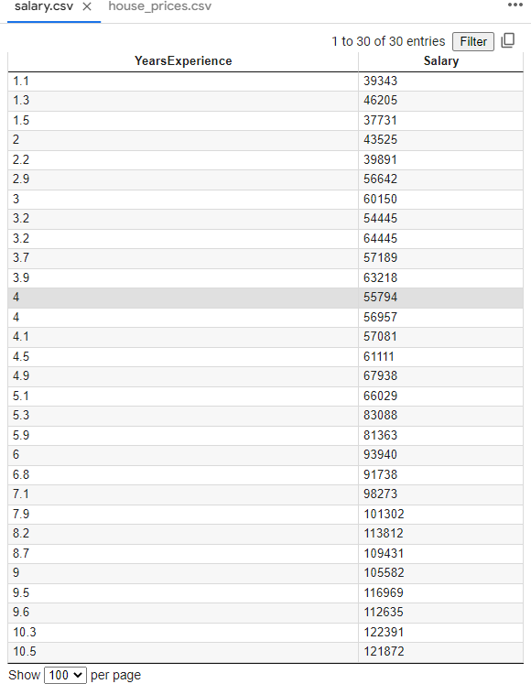

# Observation:

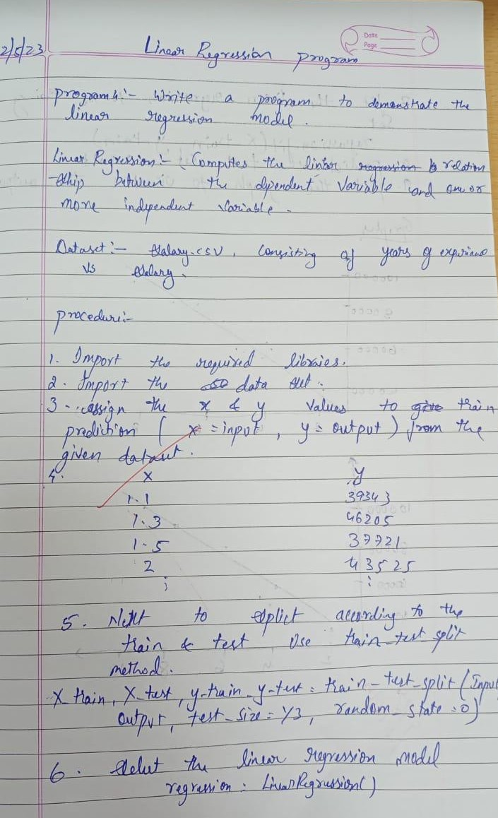

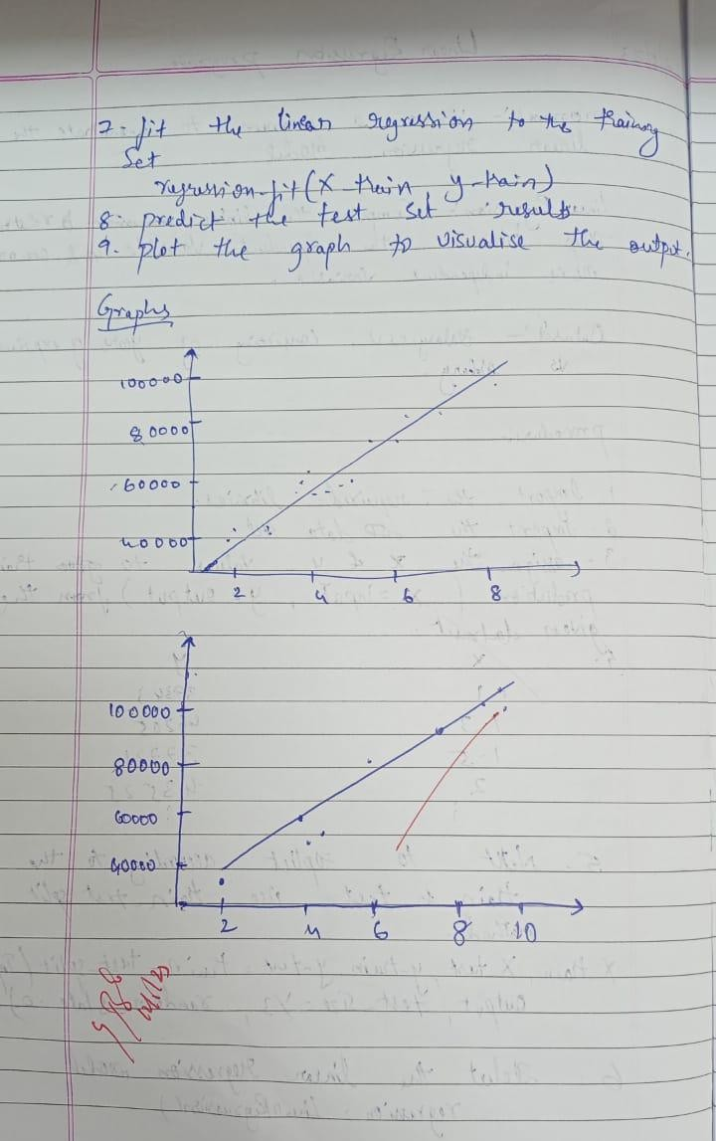

**Uploading Dataset:**

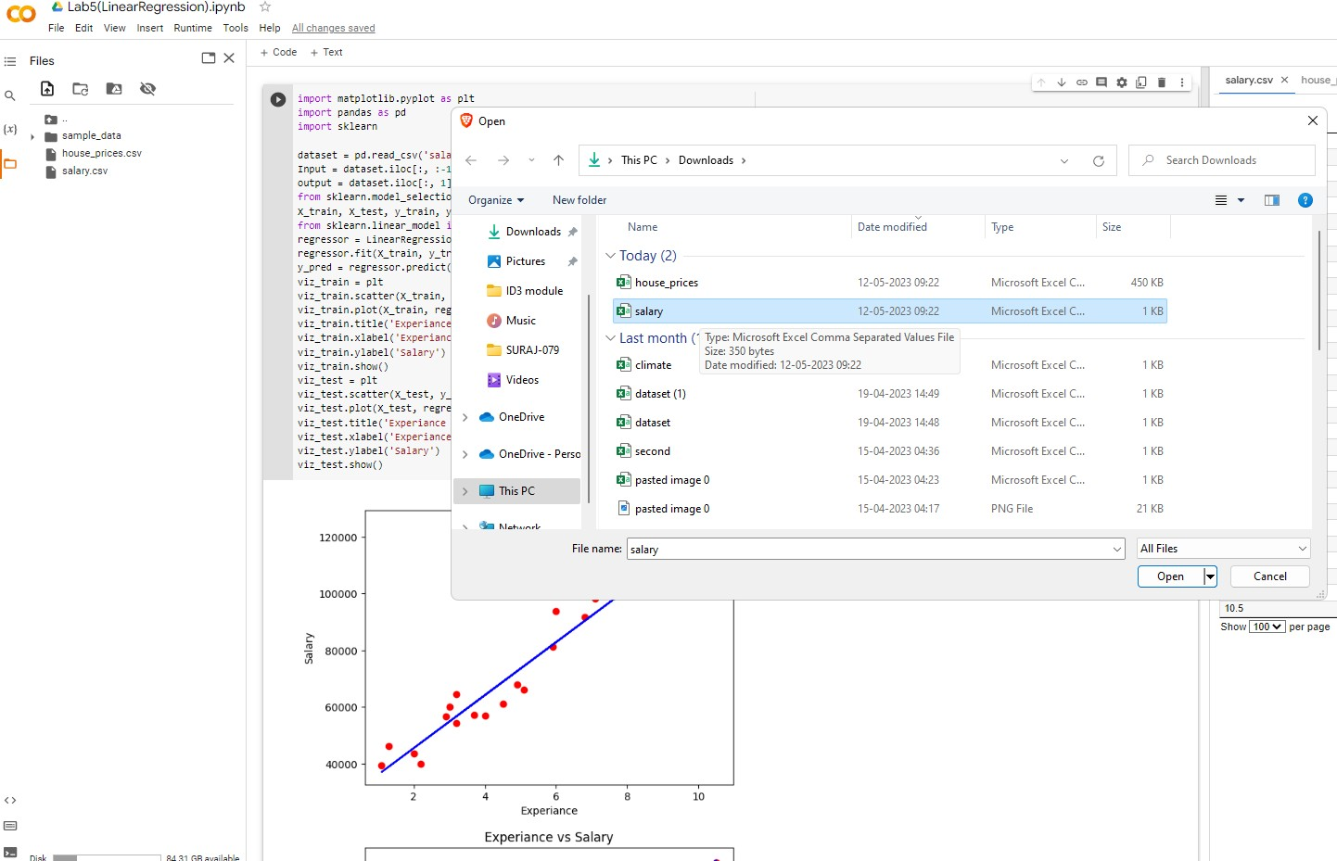

# Program:

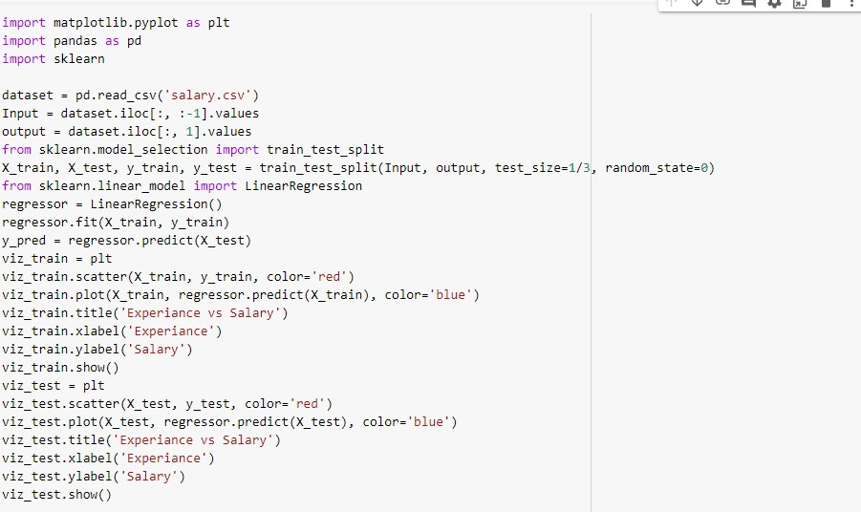

**Output:**

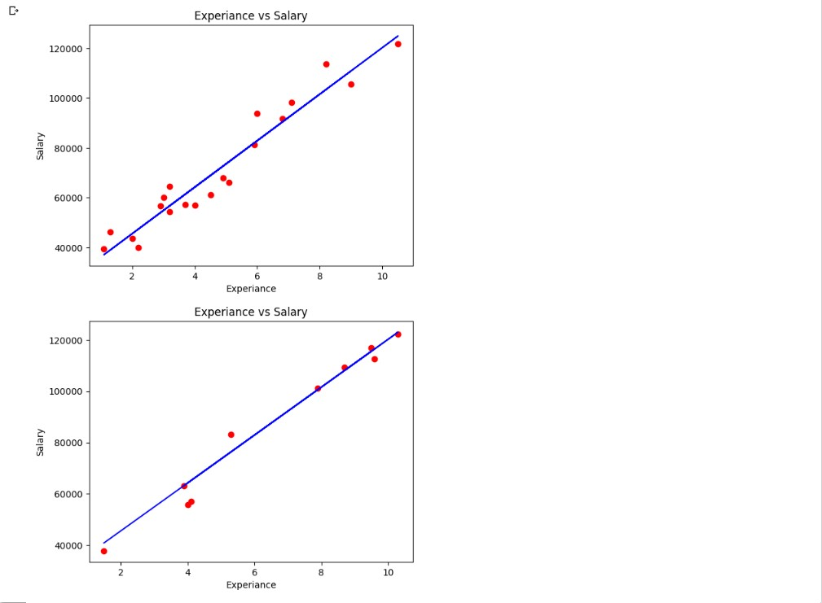

Date: 19.05.2023

**Program 5** – Write a program to construct a Bayesian network considering training data. Use this model to make predictions.

**Data set:** Climate Dataset

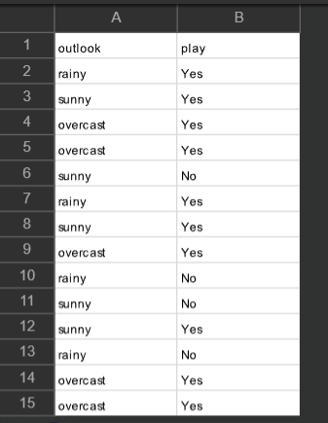

# Observation:

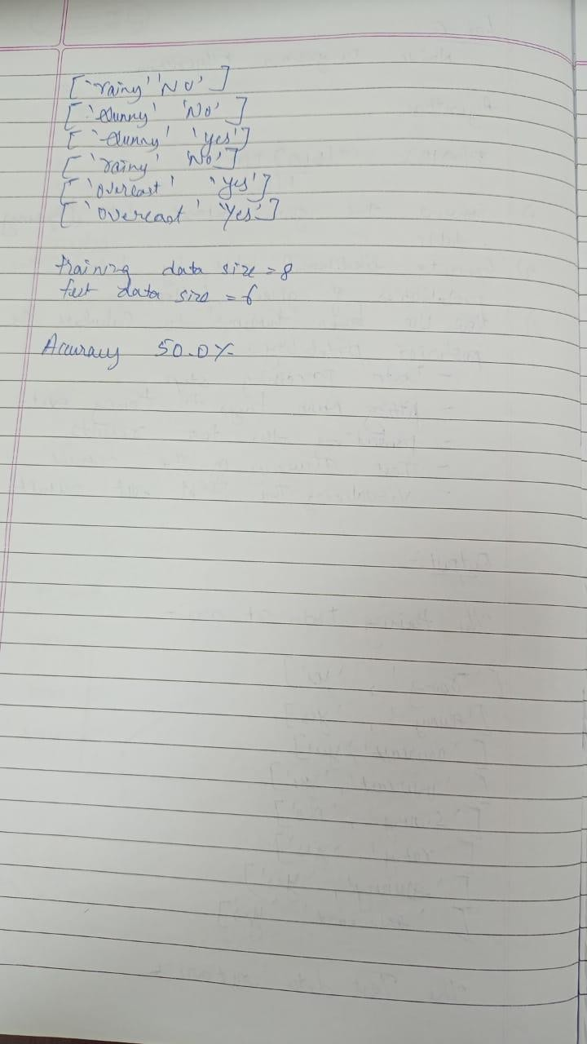

41

# Uploading csv file:

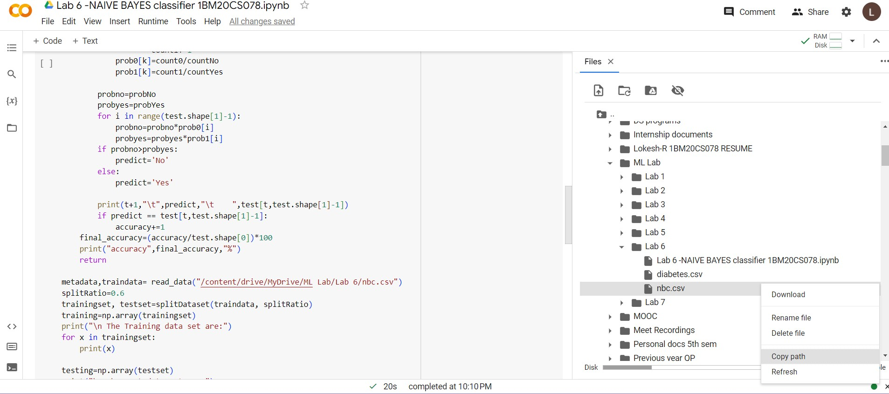

**Program Execution:**

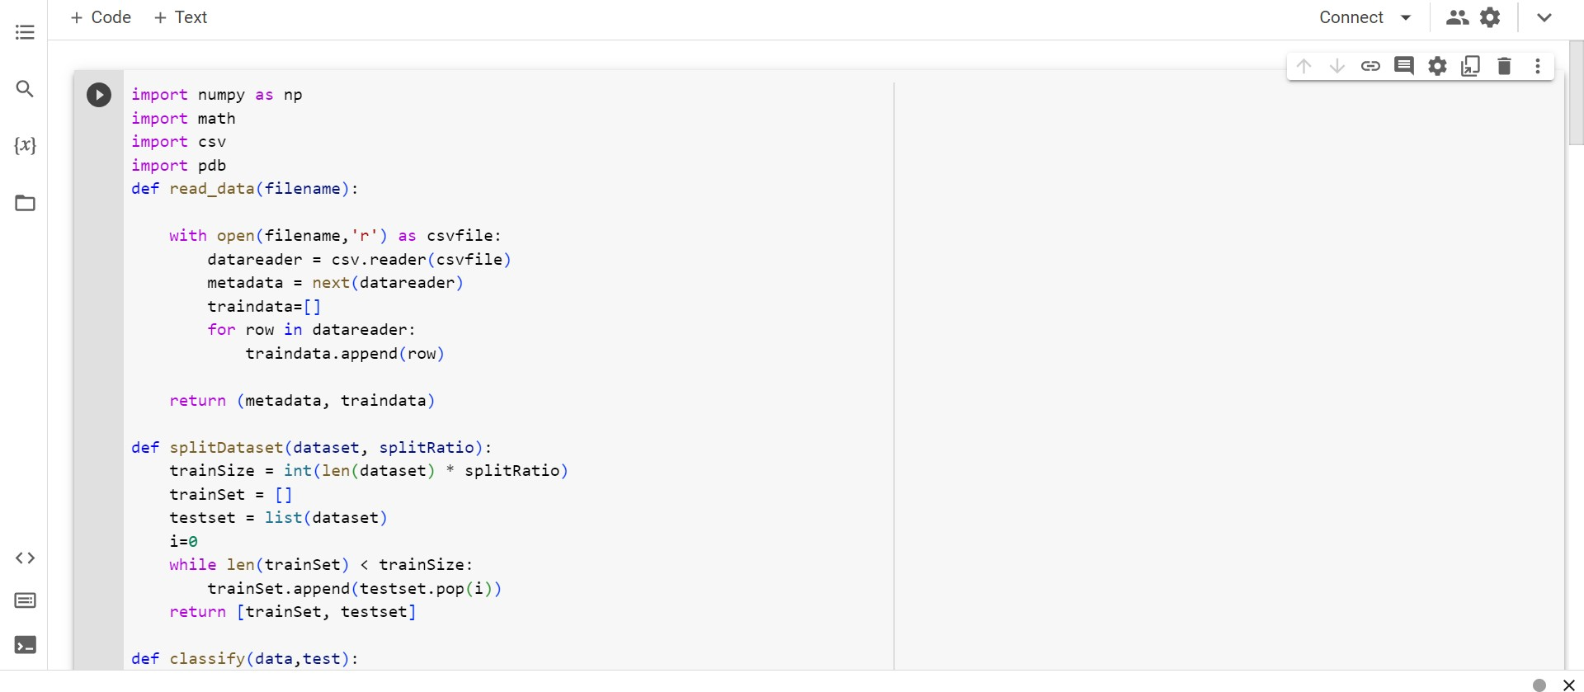

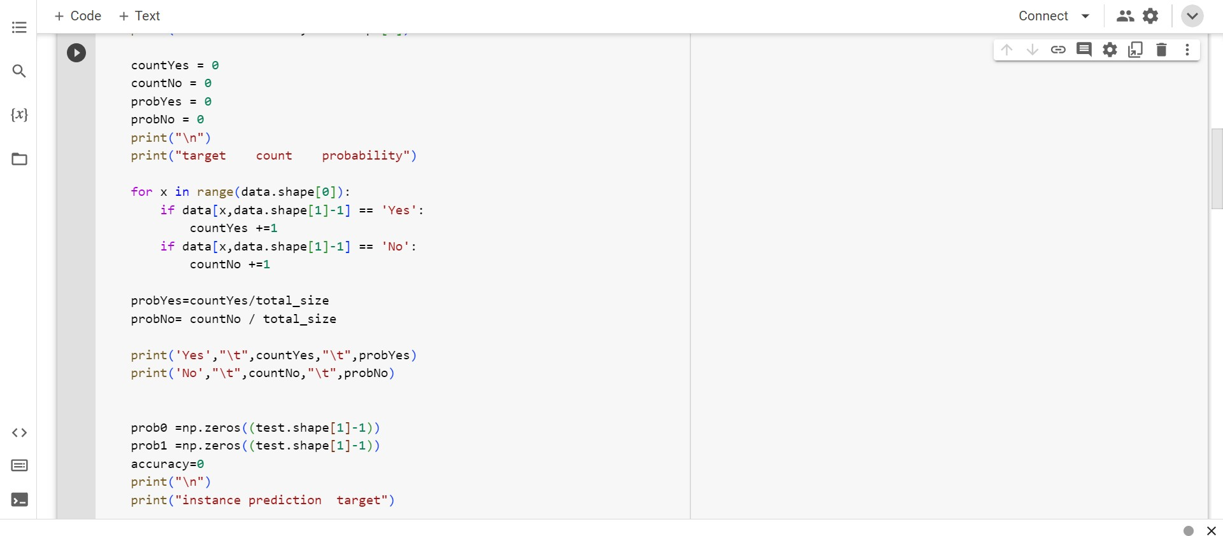

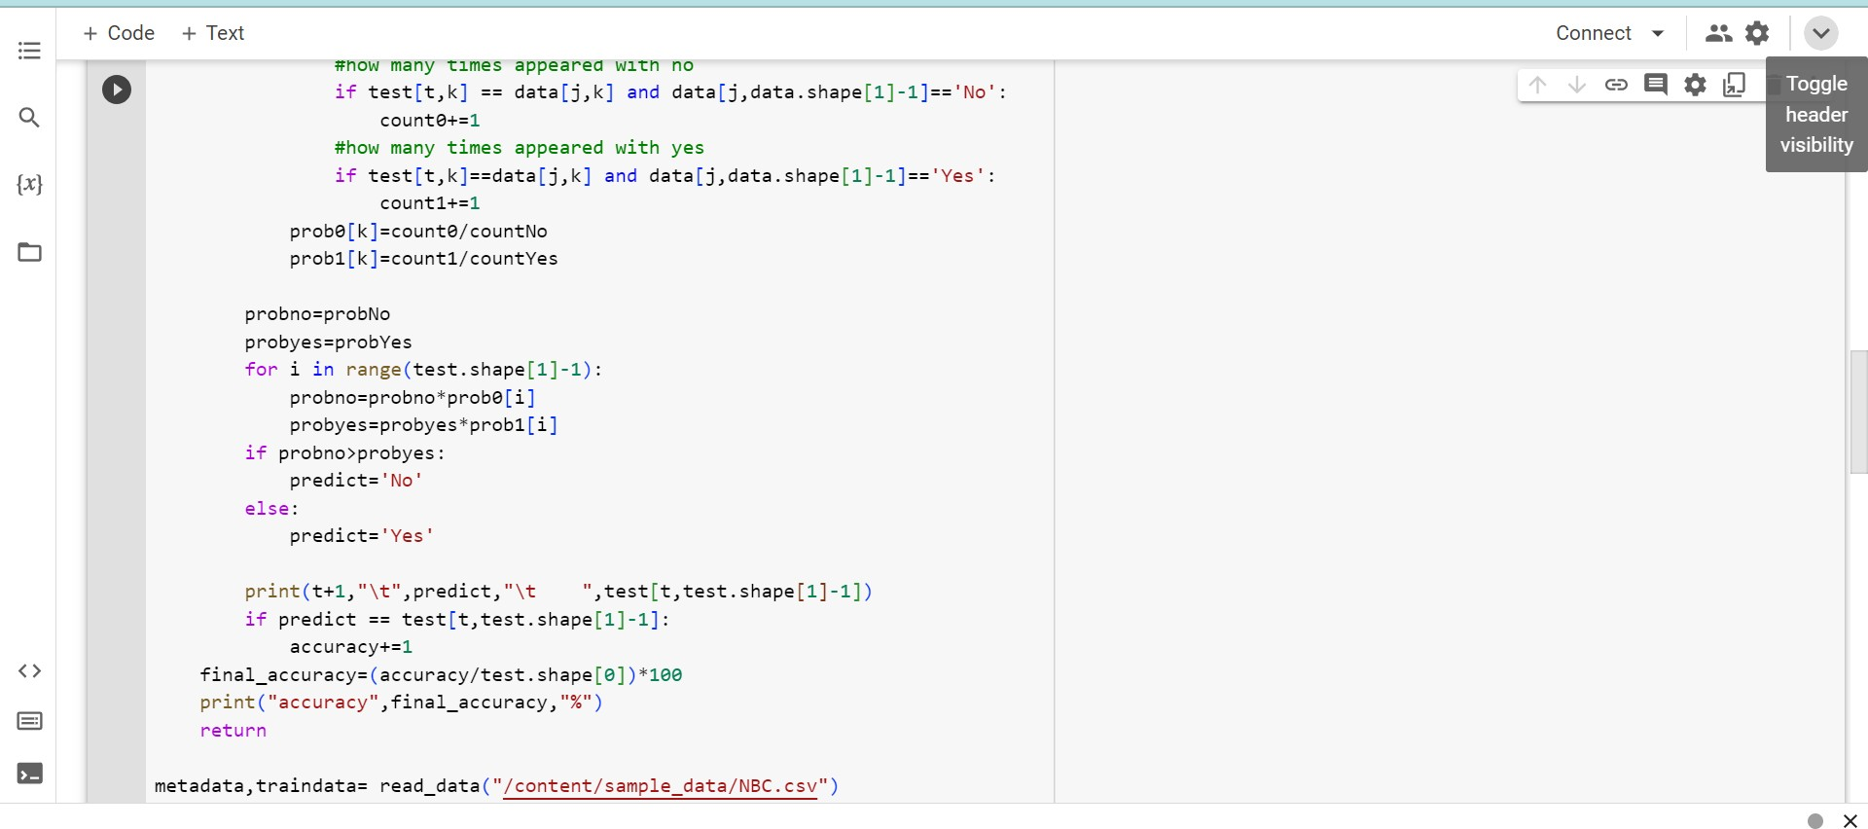

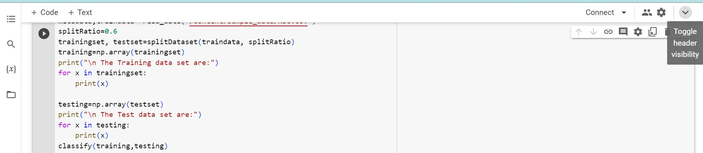

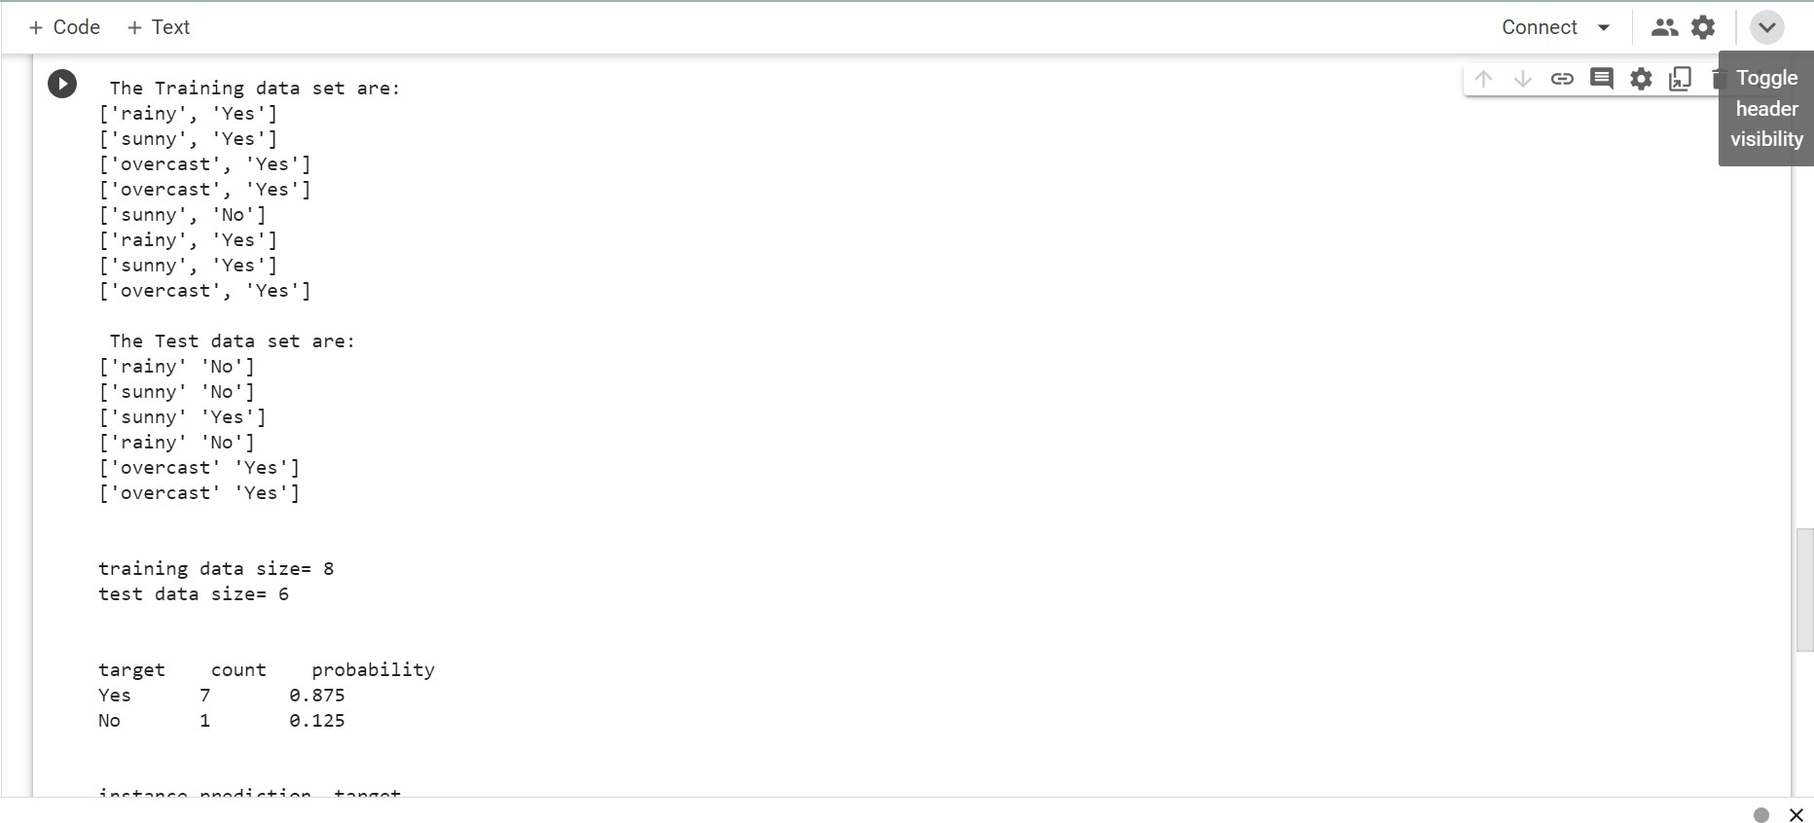**Output:**

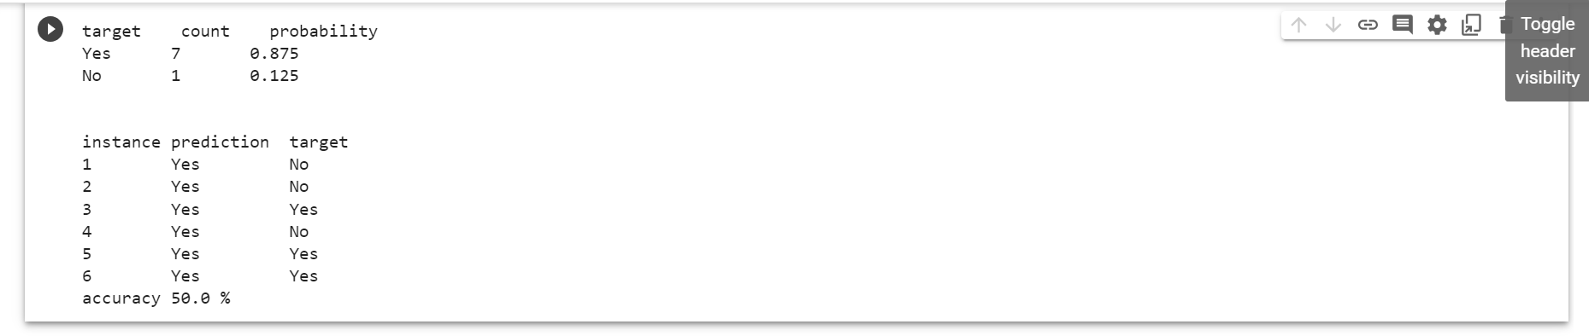

Date: 19.05.2023

**Program 7** – Apply k-Means algorithm to cluster a set of data stored in a .CSV file.

# Data set:

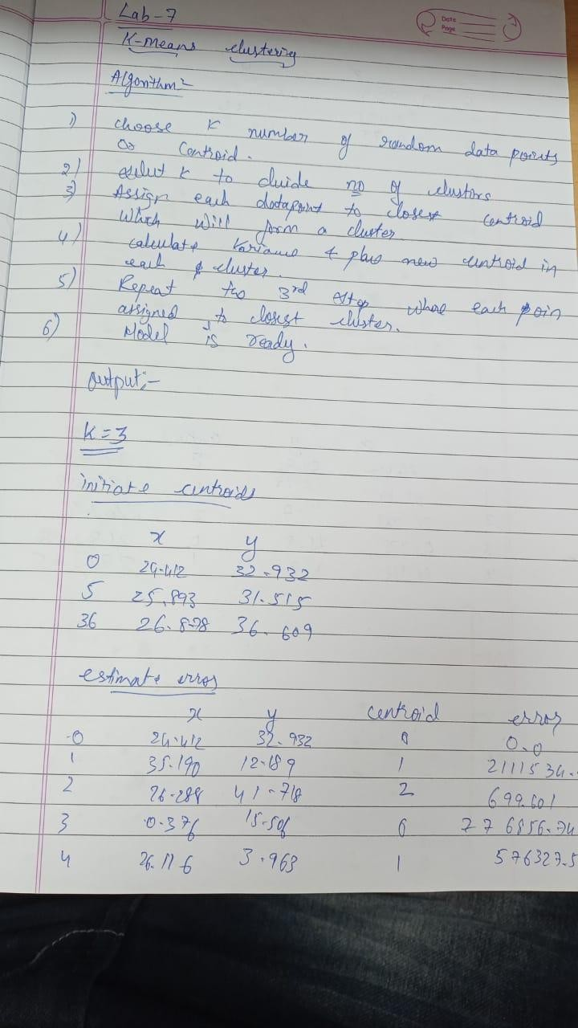**Observations:**

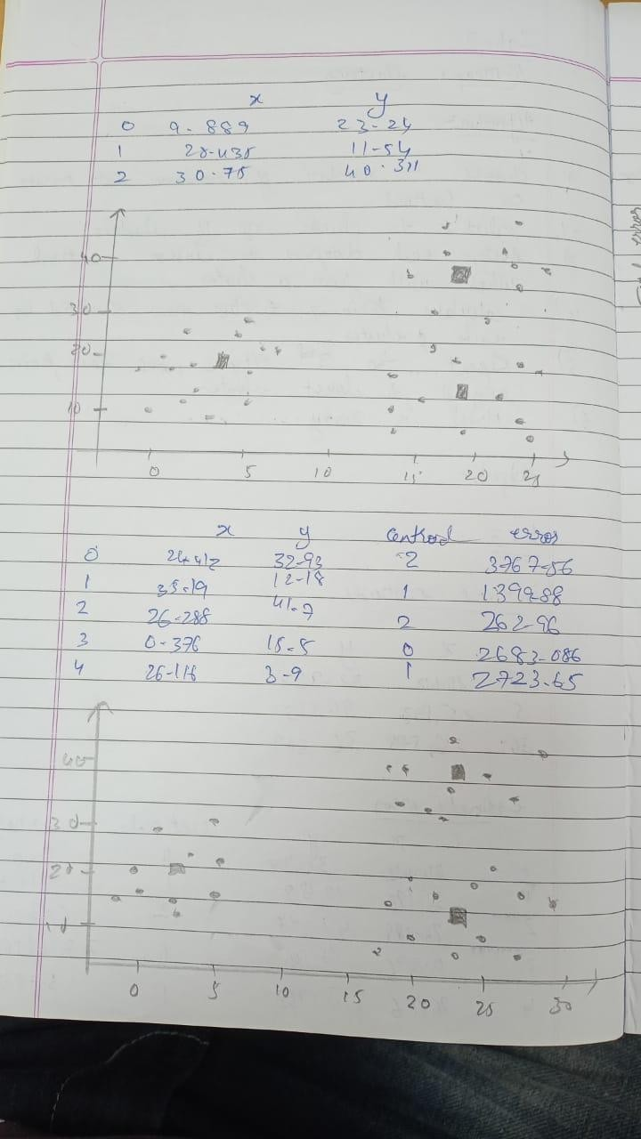

48

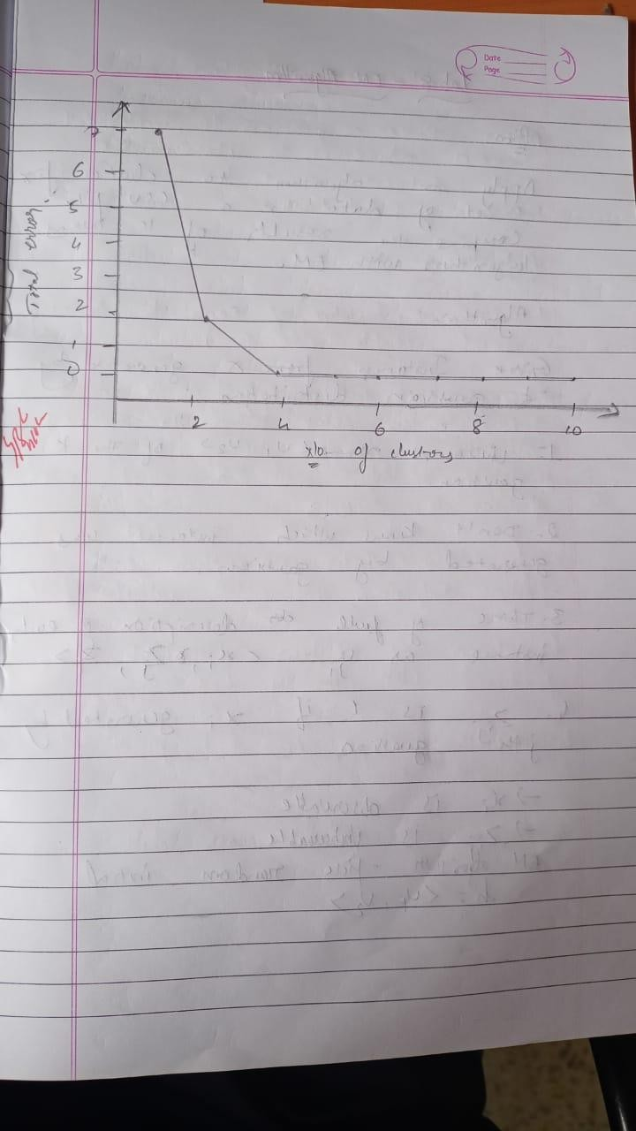

49

# Program execution:

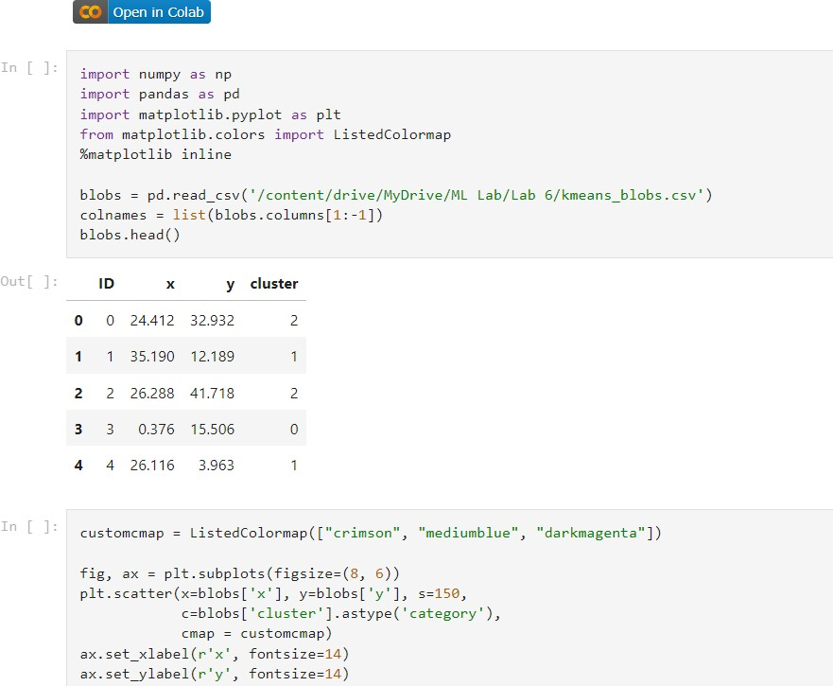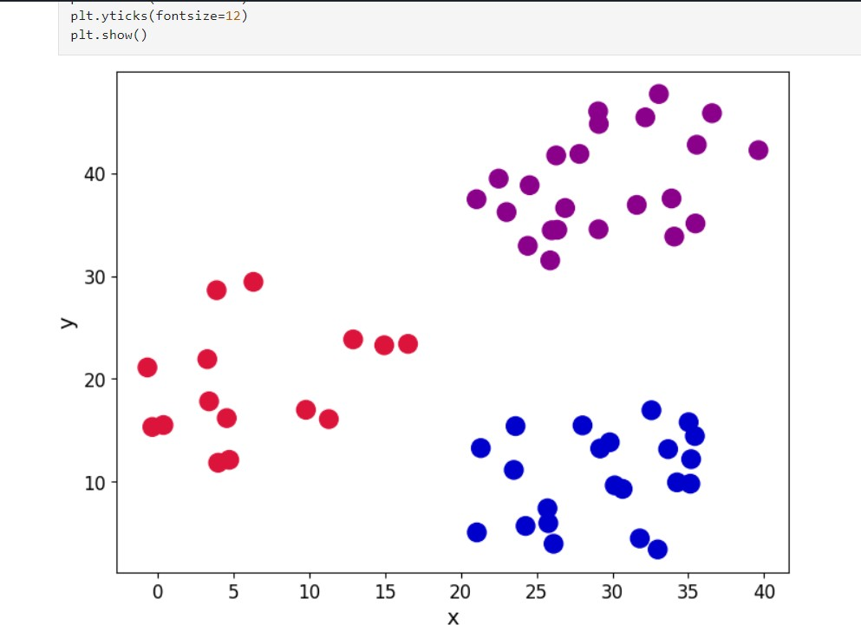

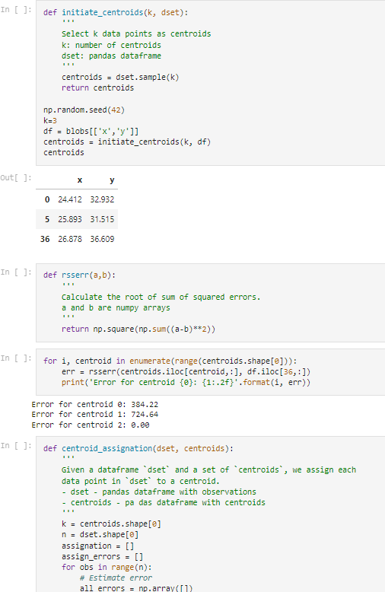

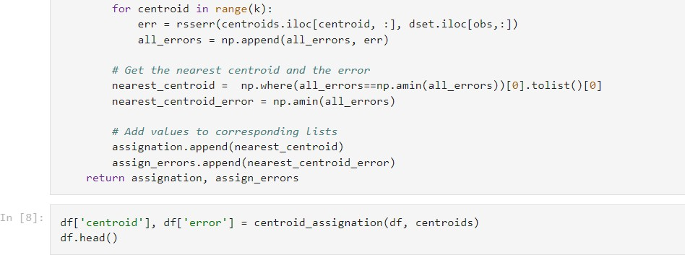

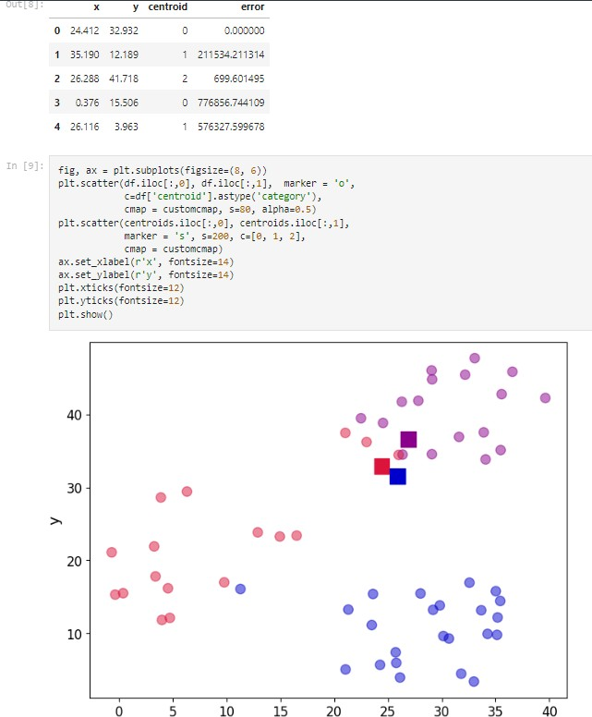

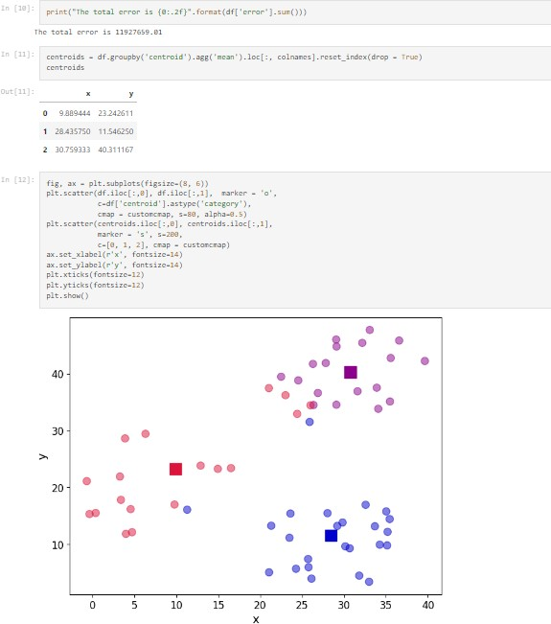

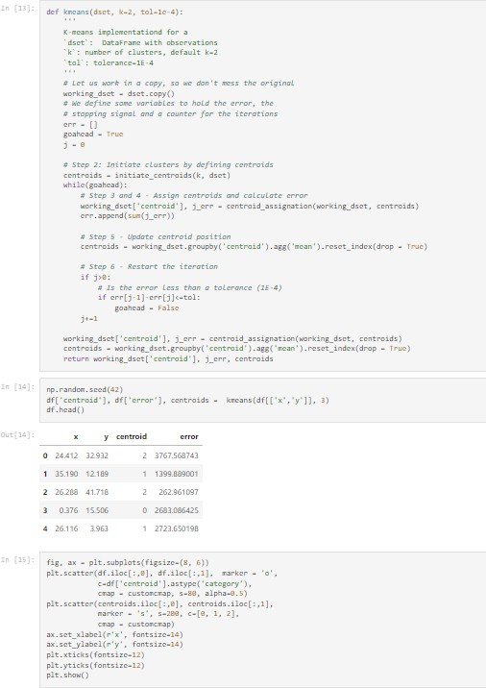

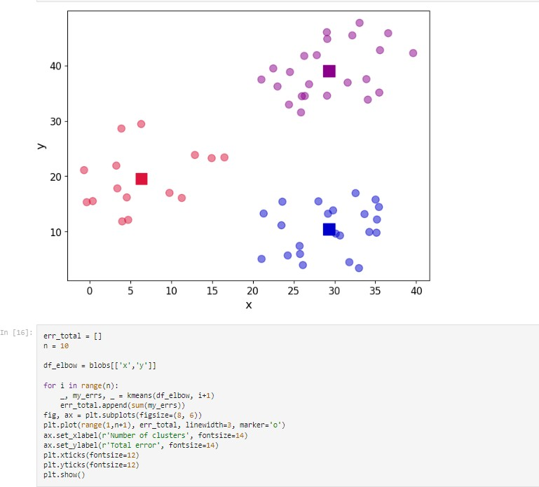

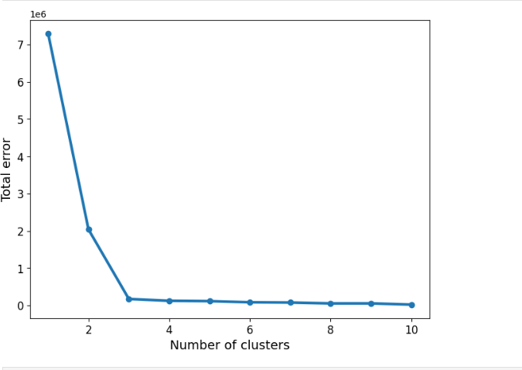

Date: 10.06.2023

**Program 8** – Apply EM algorithm to cluster a set of data stored in a .CSV file. Compare the results of k-Means algorithm and EM algorithm.

**Data set:** Iris Dataset

# Observation:

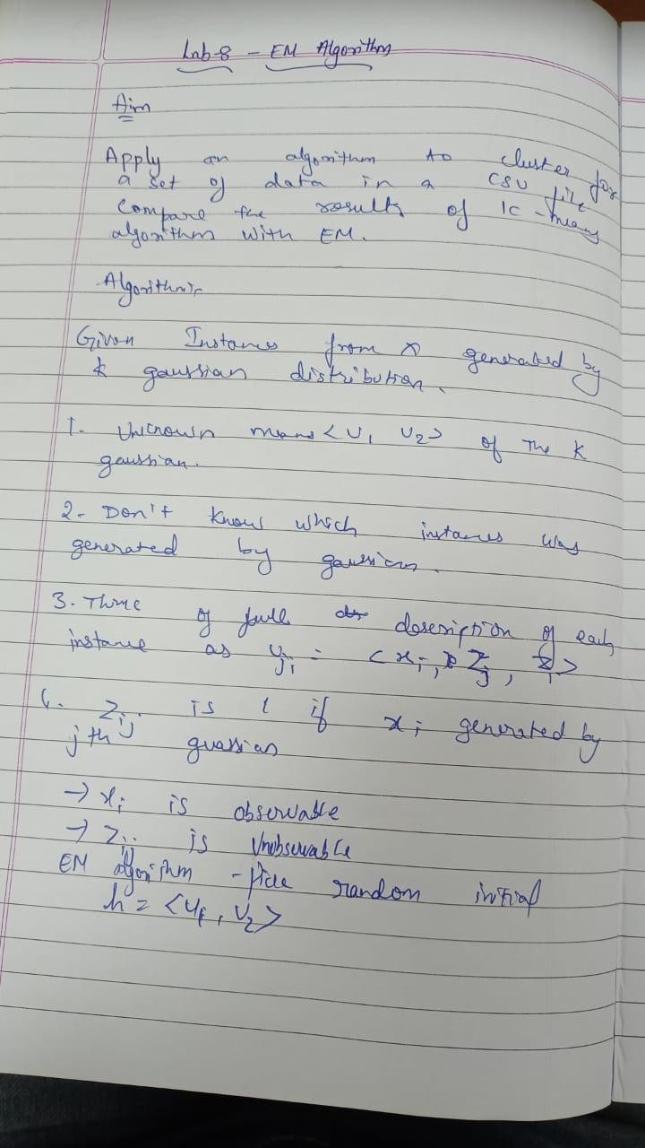

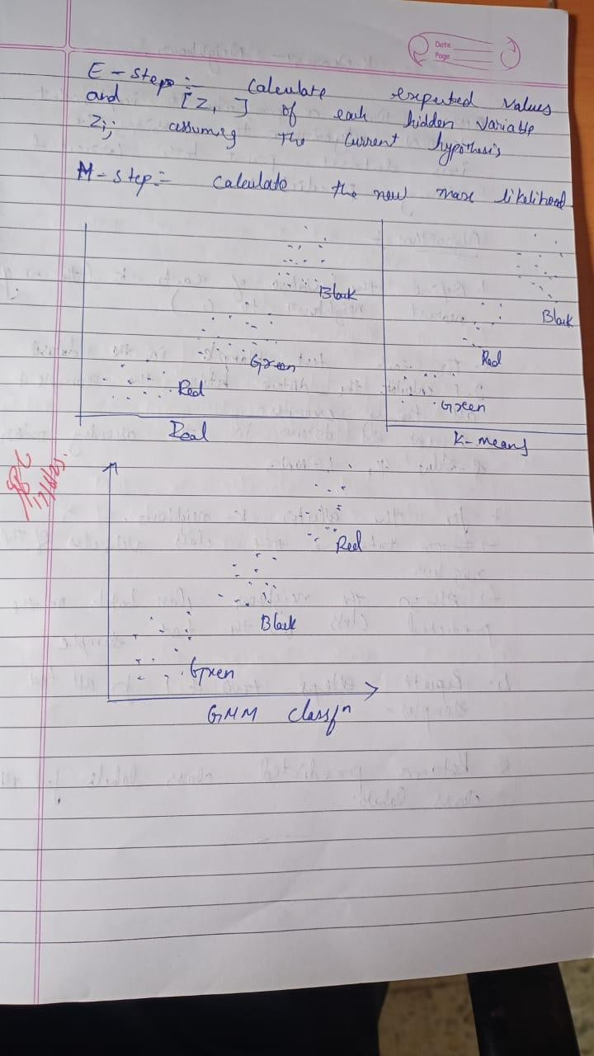

57

Program execution :

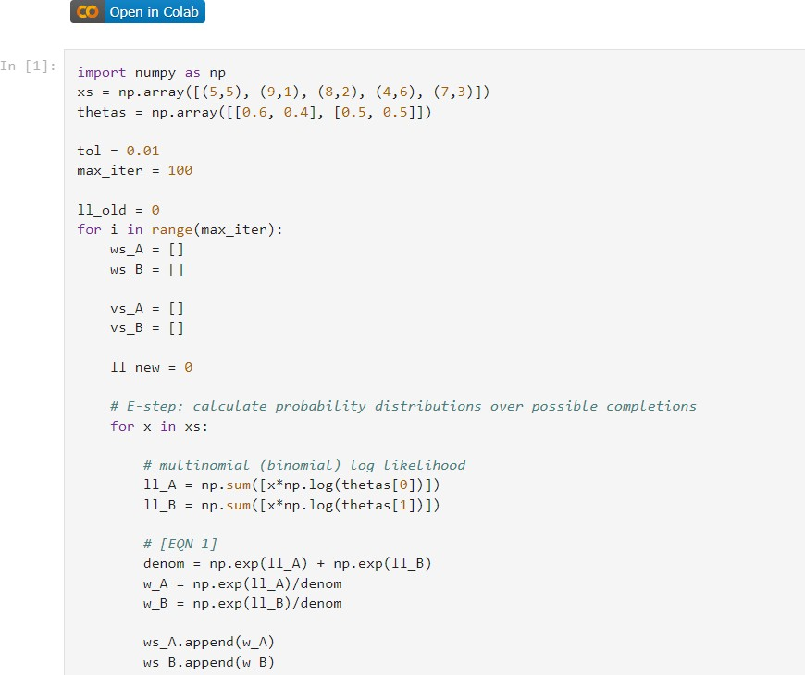

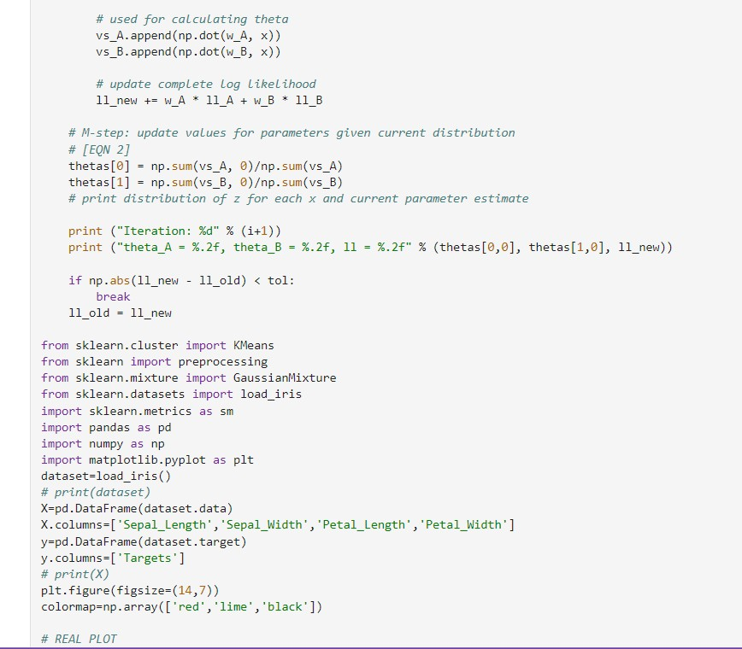

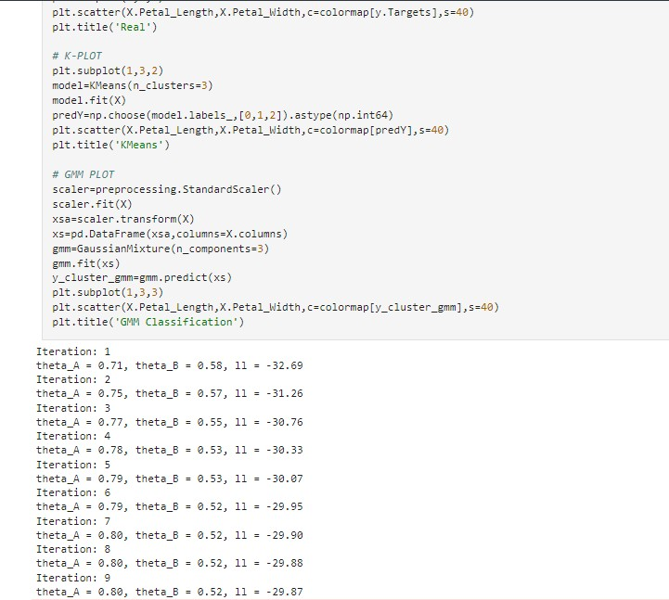

# 17.06.2023

**Program 9: Write a program to construct a Bayesian Network considering training data. Use this model to make predictions.**

# Dataset-heart

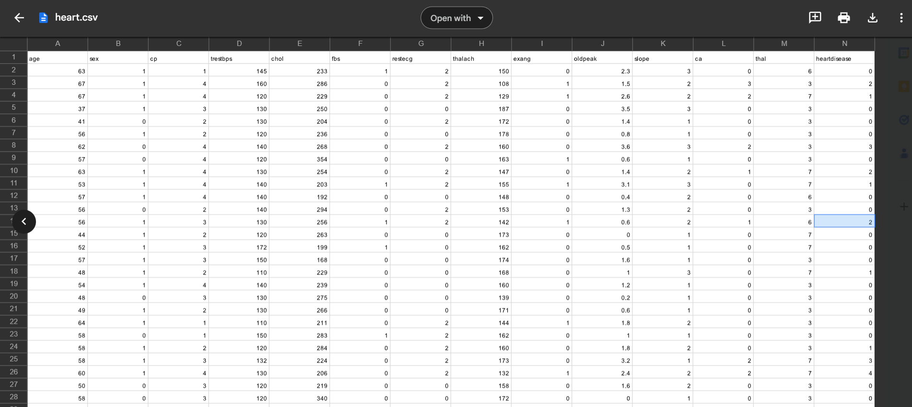

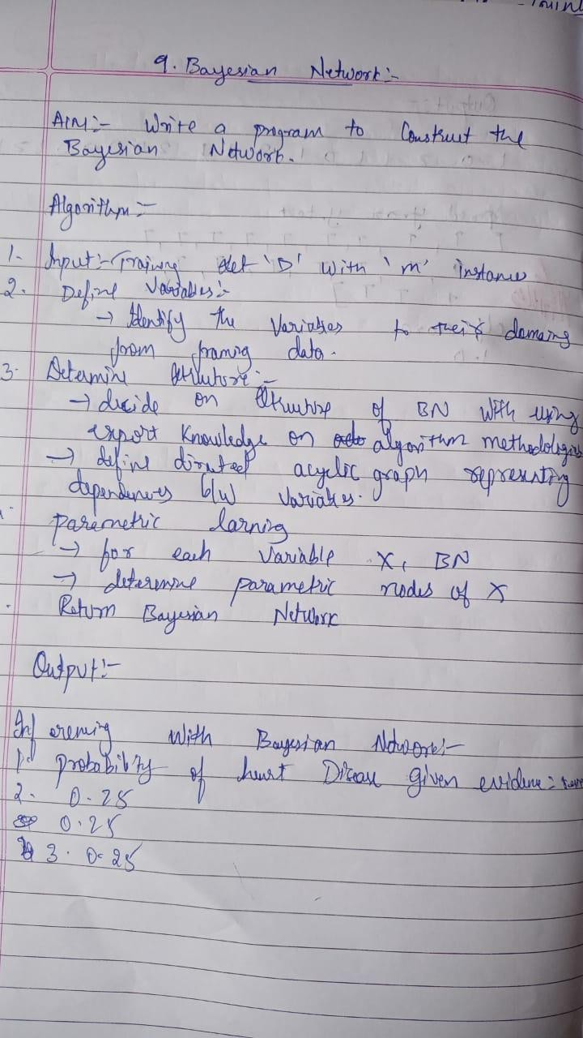**Algorithm :**

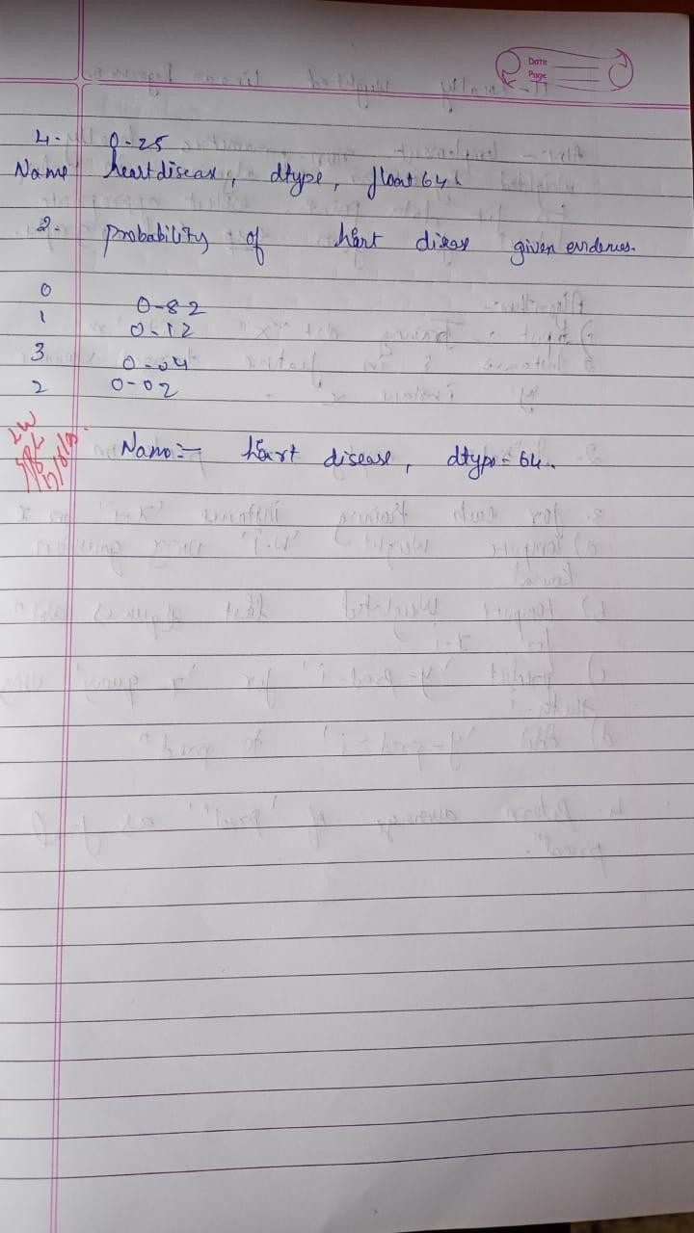

63

# Uploading csv :

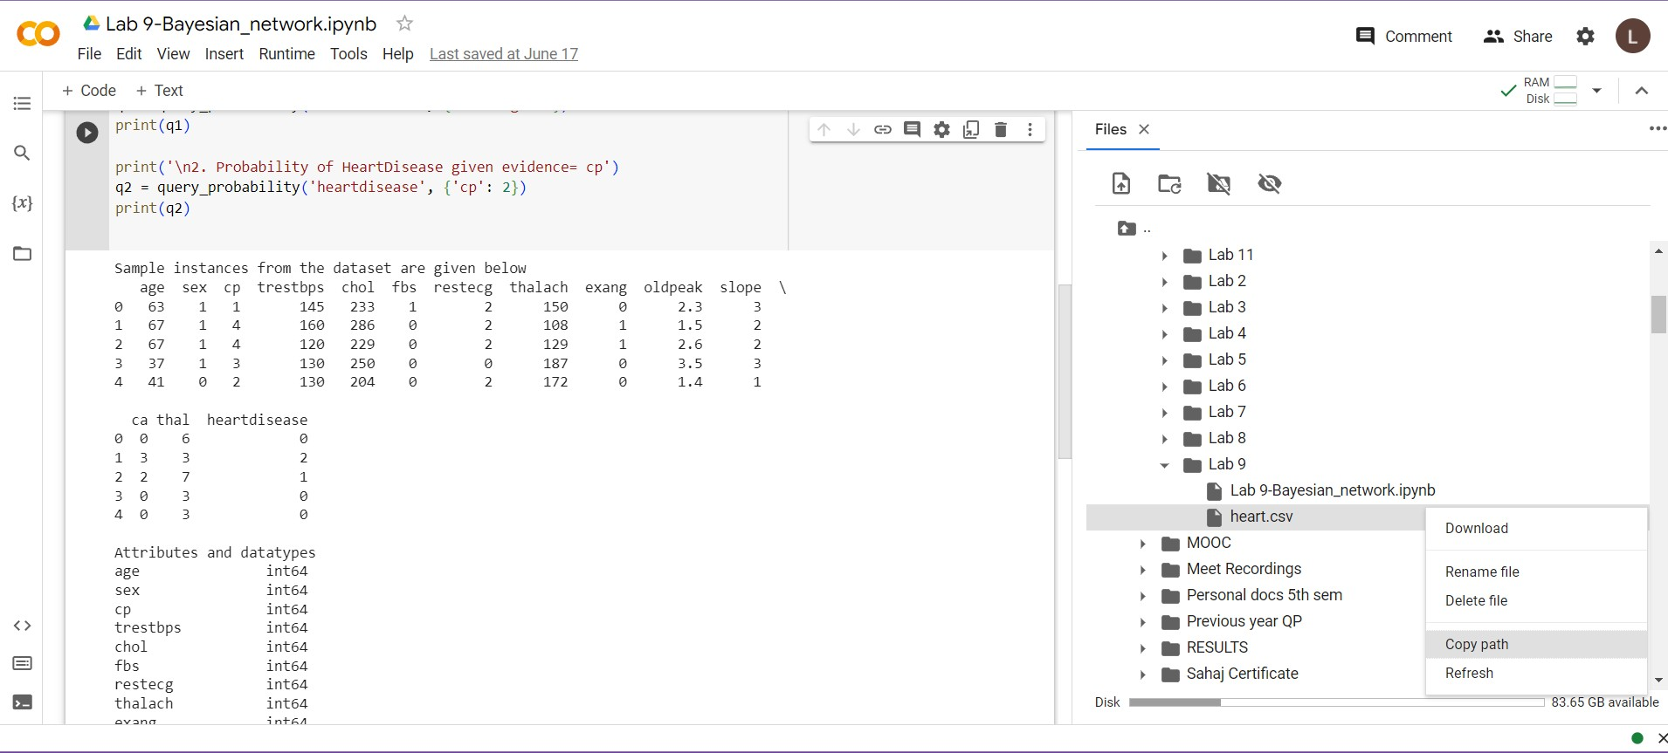

**Program execution :**

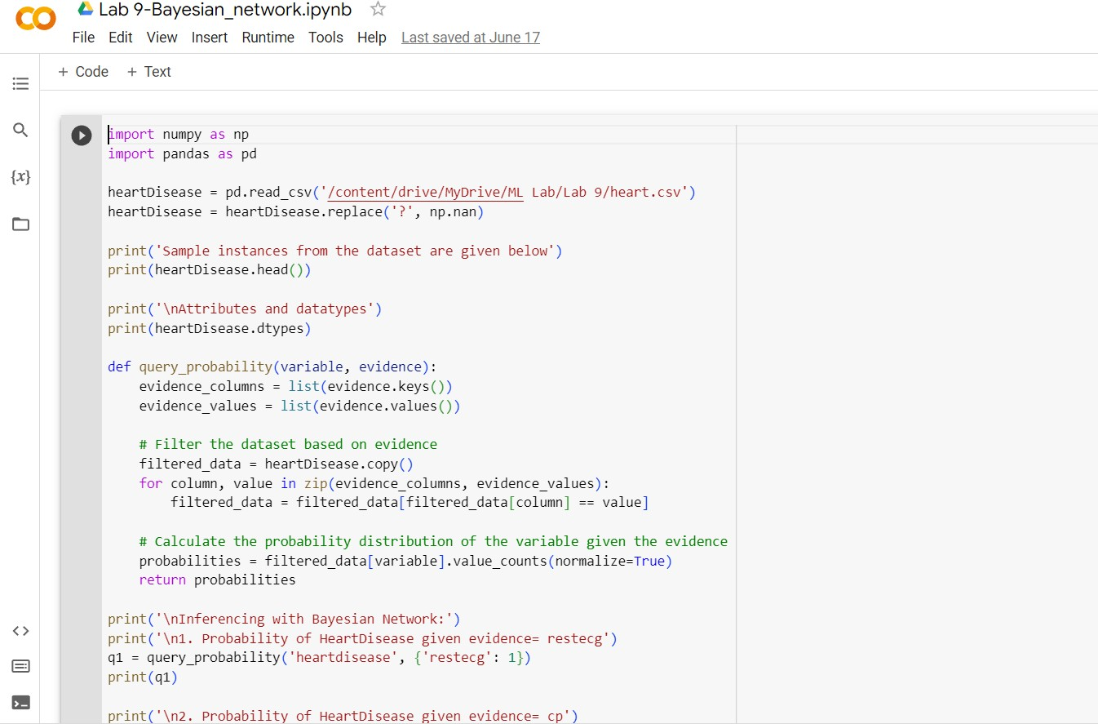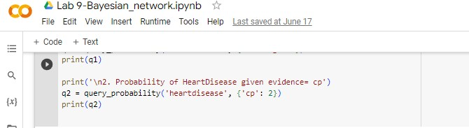

# Output:

**Date: 17.05.2023**

# Program 10:

Write a program to implement k-Nearest Neighbour algorithm to classify the iris data set. Print both correct and wrong predictions.

Dataset :Iris Dataset

# Algorithm:

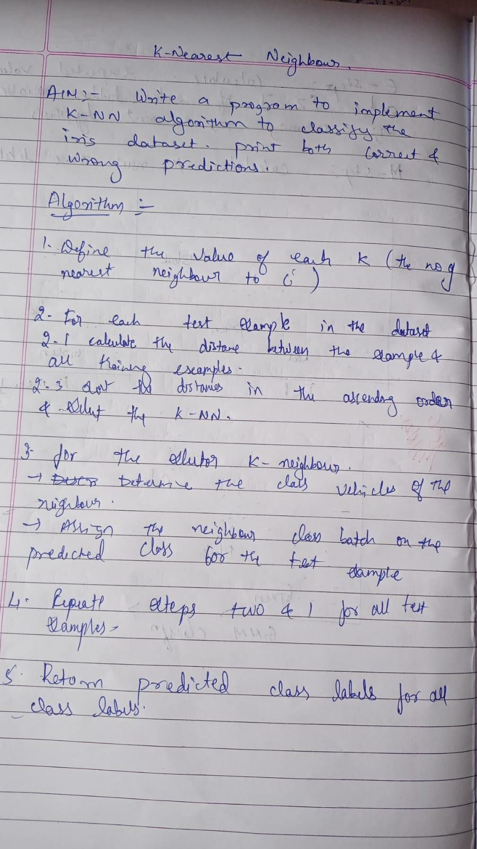

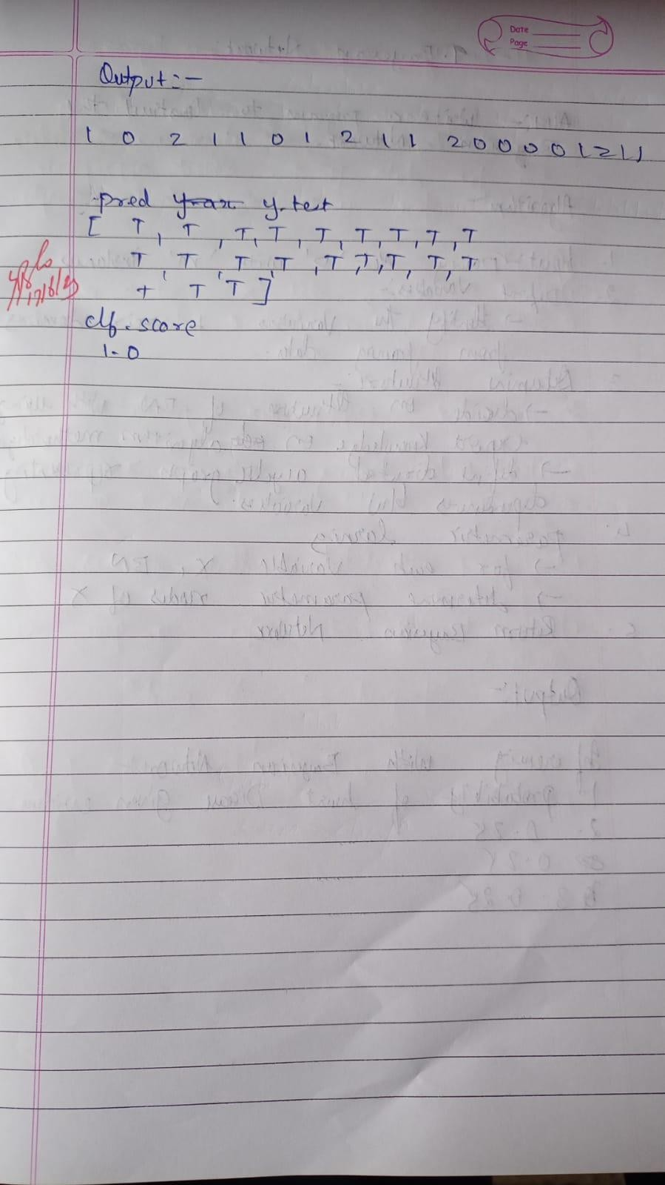

68

# Program:

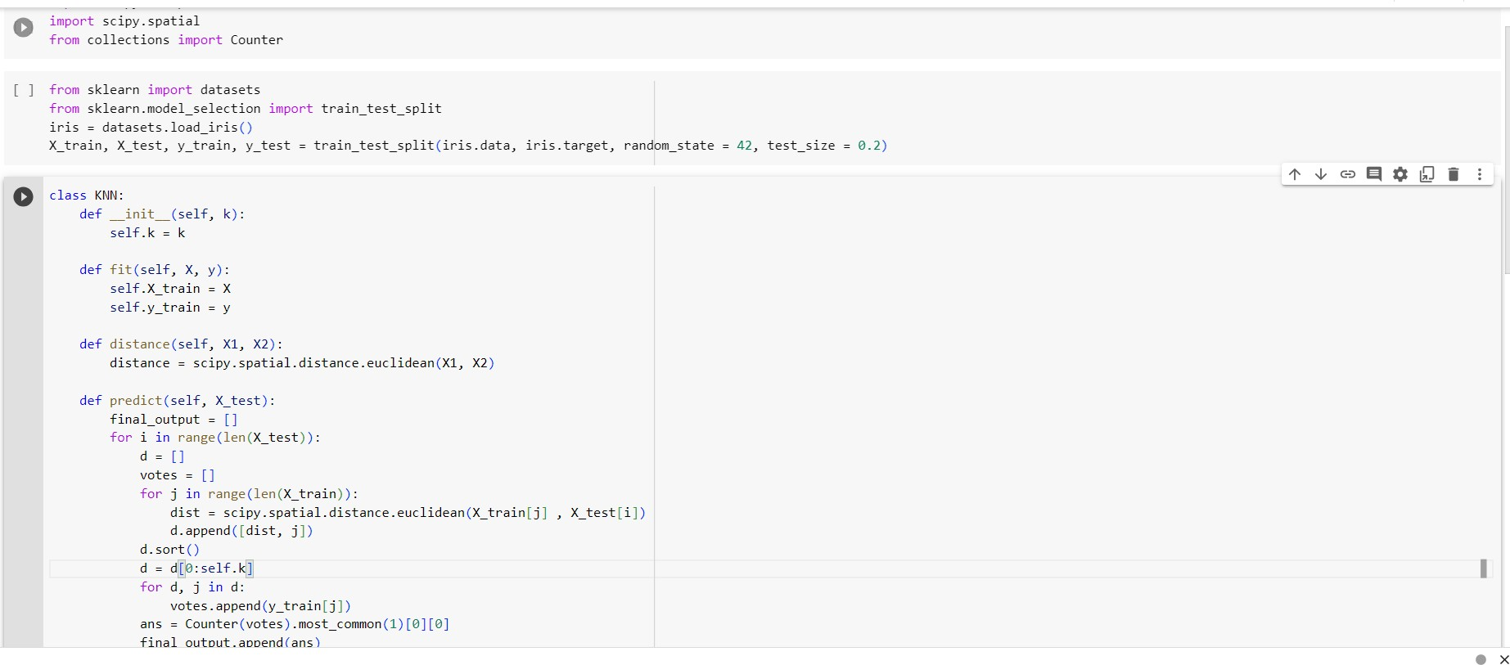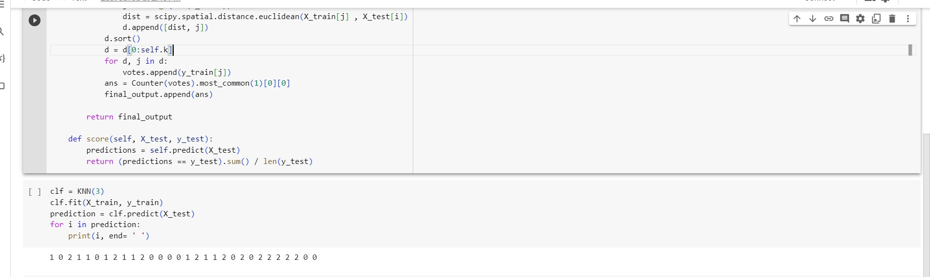

**Output:**

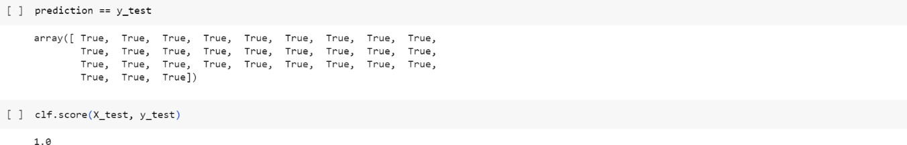

# Date: 17.05.2023

**Program 11:**

Implement the non-parametric Locally Weighted Regression algorithm in order to fit data points. Select appropriate data set for your experiment and draw graphs.

Dataset :tips.csv

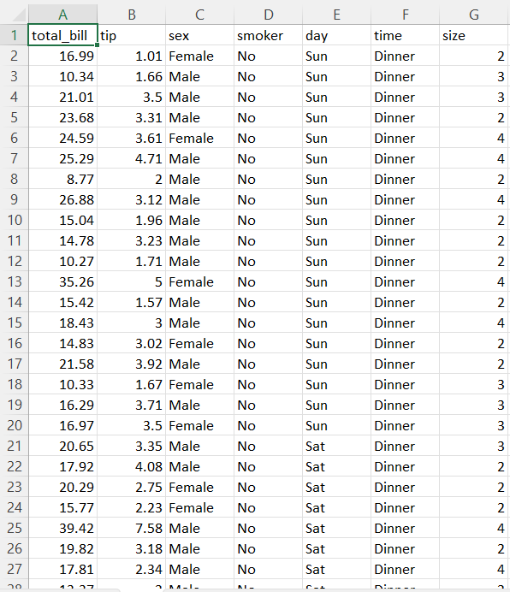

# Algorithm:

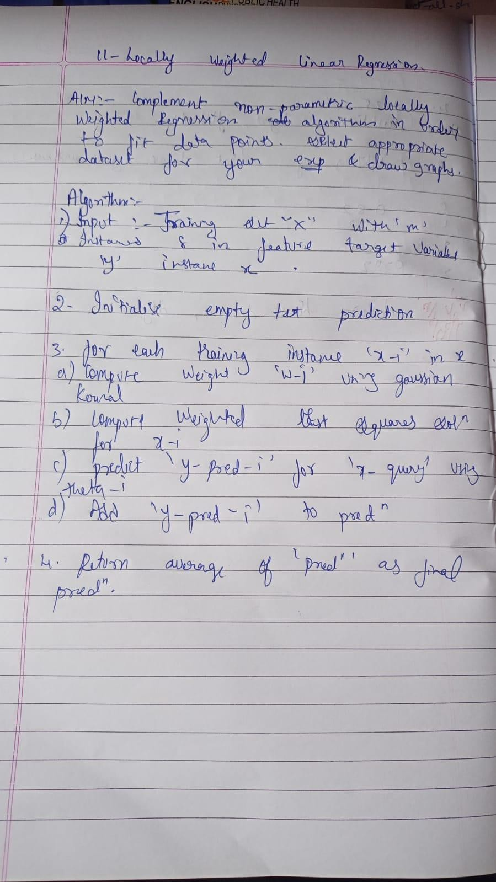

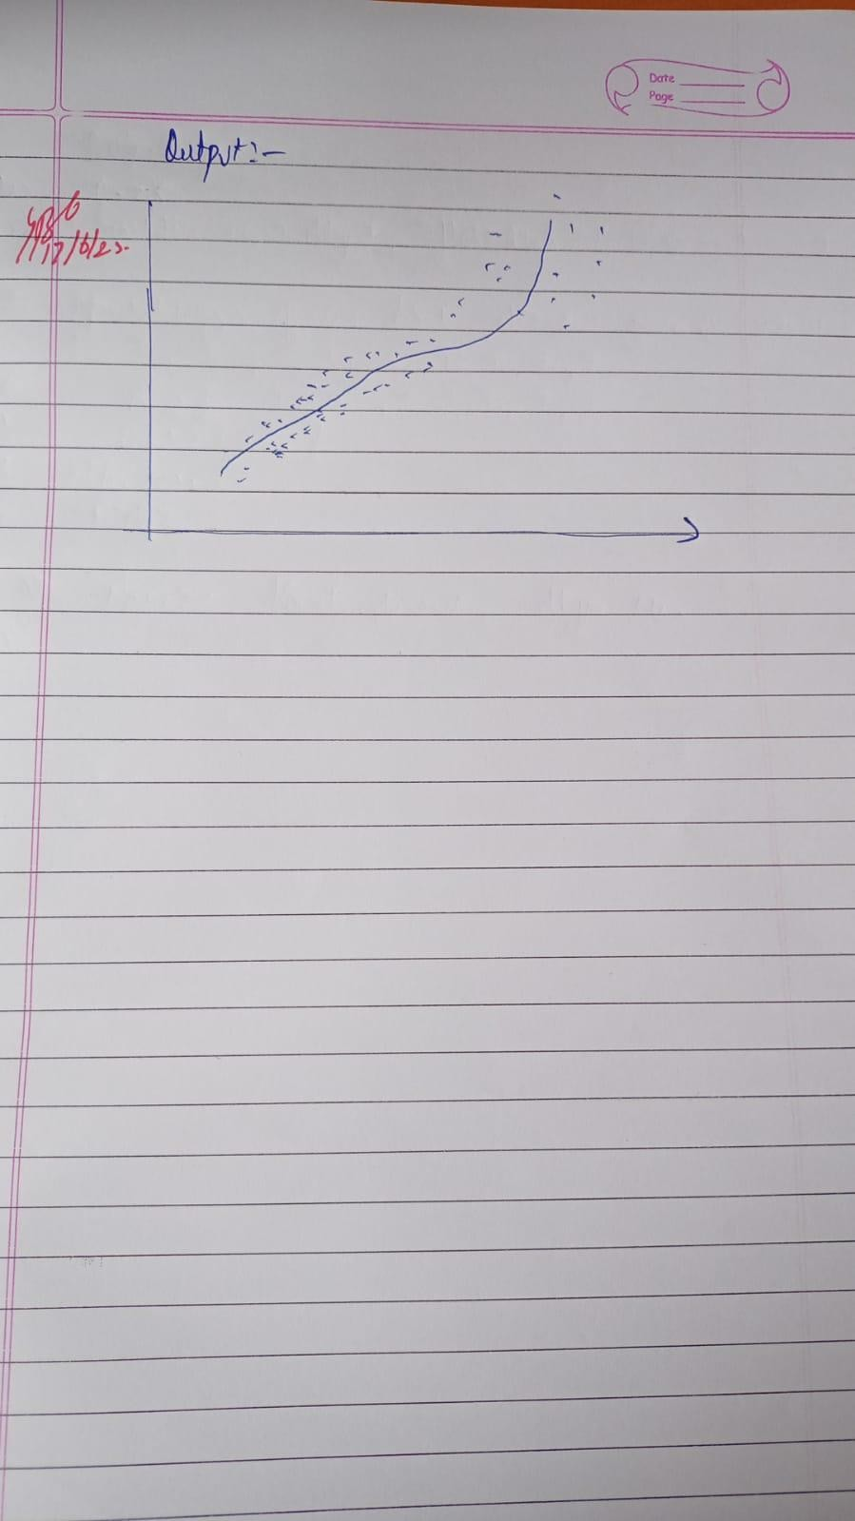

**Uploading the csv file:**

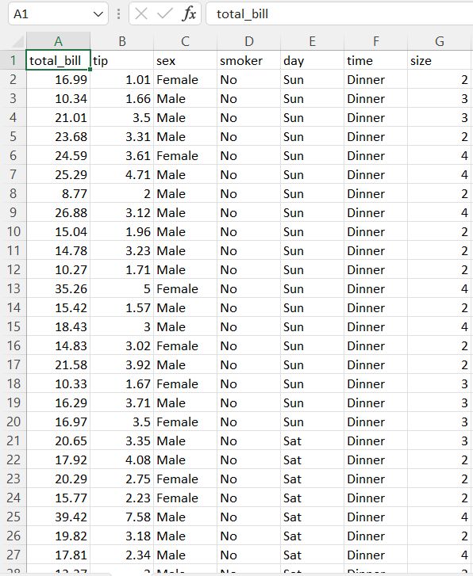

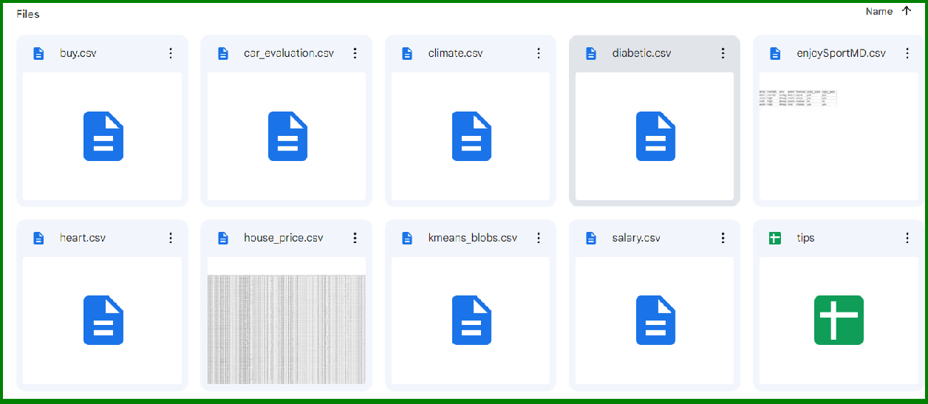

# Program:

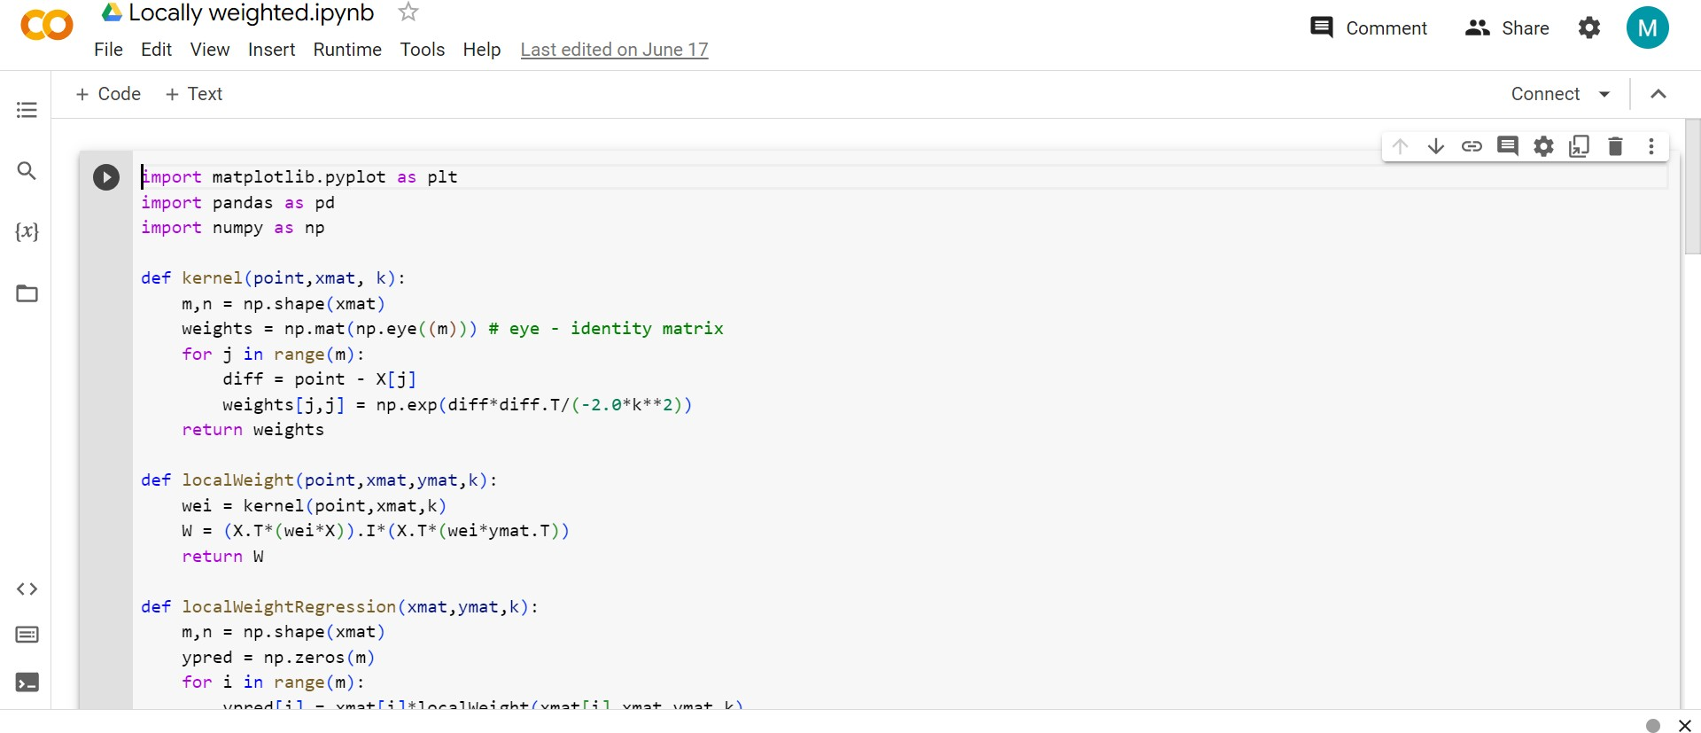

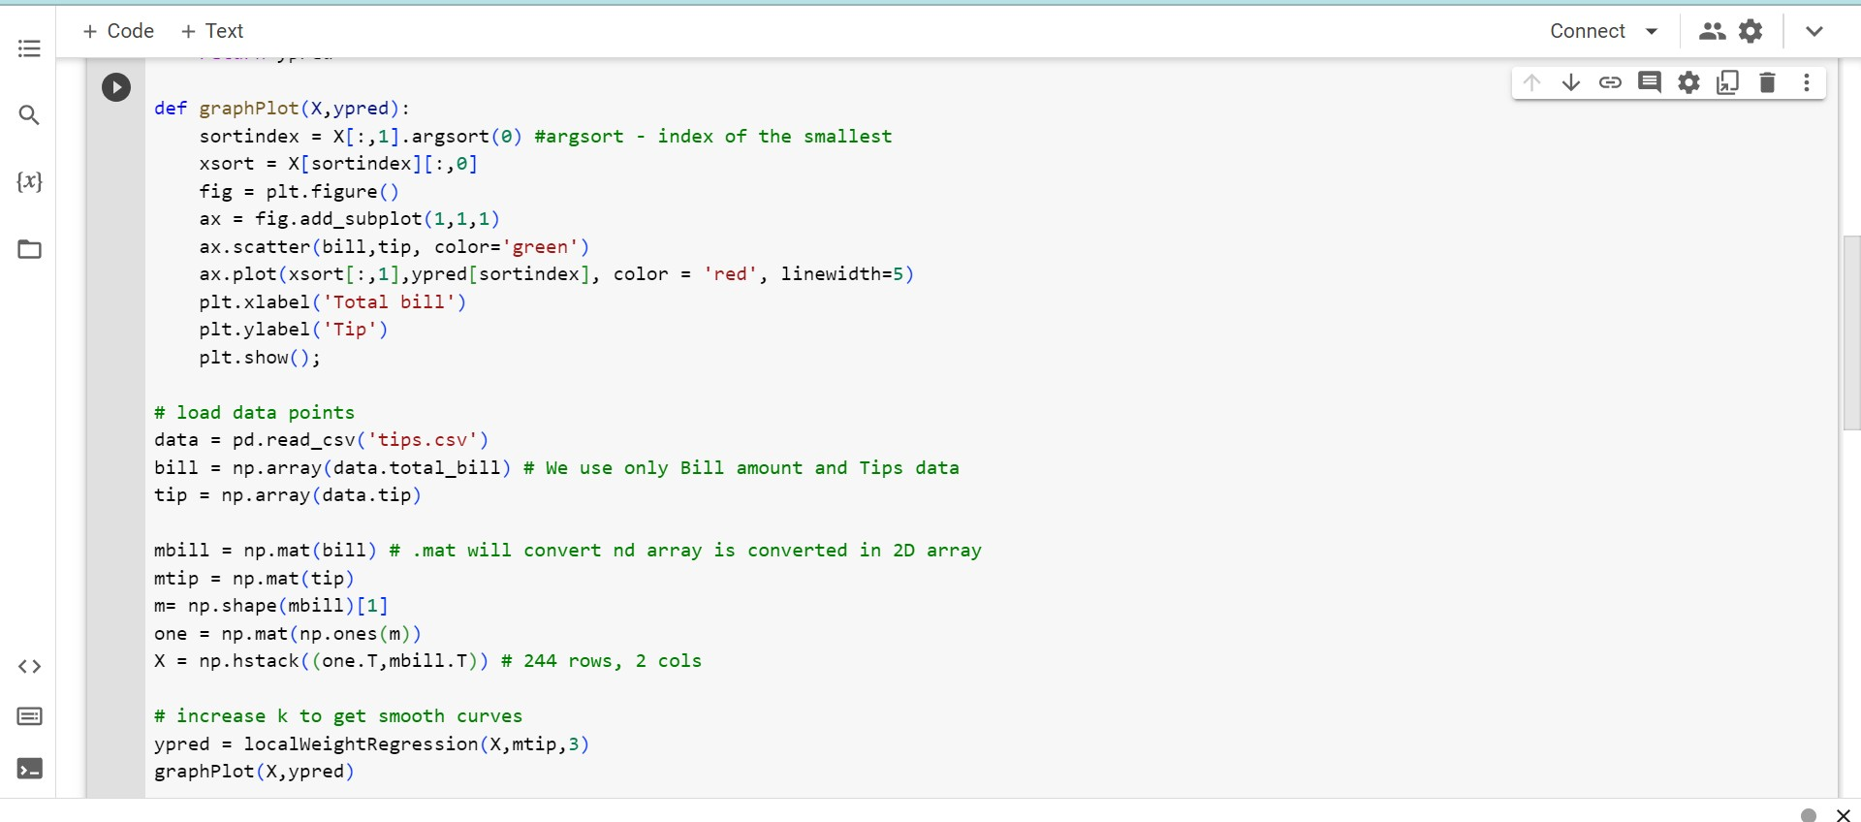

**Output:**

